

Table of Contents

PART A 7

Q1. Form tokenization and Filter stop words & punctuation [Ooi Xin Ru – TP065126] 7

*1.1* *Demonstrate word tokenization using the split function, Regular Expression and NLTK packages separately and report the output.* 7

*1.2* *Justify the most suitable tokenization operation for text analytics. Support your answer using obtained outputs.* 10

*1.3 Demonstrate stop words and punctuations removal and report the output suitably along with the stop words found in the given text corpus.* 10

*1.4 Explain the importance of filtering the stop words and punctuation in text analytics.* 11

Q2 Form word stemming [Soo Jiun Guan – TP068687] 12

*2.1 Explain the importance of stemming in text analytics* 12

*2.2 Demonstrate word stemming using Regular Expression, Porter Stemmer and Lancaster Stemmer and report the output* 13

*2.3 Explain the differences among Regular Expression stemmer, Porter Stemmer and Lancaster Stemmer using the obtained output* 15

Q3 Form Parts of Speech (POS) Taggers & Syntactic Analysers [Aidan Chang Wai Yue – TP063411] 15

*3.1 Demonstrate POS tagging using NLTK POS tagger, TextBlob POS tagger and the Regular Expression tagger and report the output* 16

*3.2 Explain the differences of the POS taggers using the output obtained in the above question* 18

*3.3 Draw possible parse trees for the given sentence using suitable python codes and report the output along with the code* 19

Q4 Work on sentence probabilities [Soong Yau Joe – TP068977] 21

*4.1 Compute manually the sentences probabilities using the unsmoothed bigram model.* 21

*4.2 Compute manually the sentences probabilities using the smoothed bigram model.* 22

*4.3 Implement in python using both unsmoothed and smoothed bigram language models and report the respective sentence probabilities.* 24

PART B 27

Introduction 27

Literature Review 27

Exploratory Data Analysis (EDA) and Preprocessing 29

Import and Display Basic Information of Data 29

Change Variable Type 30

Find and Remove Duplicate Rows 31

Words Exploration 32

Explore and Handle URL Related Words in Text 33

Q2 – Base Model Building 41

2.1 Multinomial Naïve Bayes (MNB) Classifier 41

2.2 Support Vector Machine (SVM) 43

2.3 Random Forest 45

2.4 Gradient Boosting Machine 47

Q3 – Hyperparameter Selection 49

3.1 Hyperparameter Explanation 49

3.2 Hyperparameter Tuning 53

Q4. Evaluation and Discussion of Predictive Model’s Results 59

4.1 Evaluation Metrics 59

4.2 Result Evaluation 60

4.3 Model Comparison 63

References 65

**Table of Figures**

Figure 1: NLTK 7

Figure 2: Regular Expression 8

Figure 3: Split function 8

Figure 4: Unique Tokens 9

Figure 5: Stop words and punctuations removal 10

Figure 6: Stemming algorithms 13

Figure 7: Output of stemming algorithms 14

Figure 8: Data_2.txt’s content. 15

Figure 9: Installing the NLTK library. 16

Figure 10: POS tagging with NLTK’s POS tagger. 16

Figure 11: POS tagging with TextBlob. 17

Figure 12: POS Tagging with Regular Expression. 17

Figure 13: Parse tree. 19

Figure 14: Parse tree from IDE 20

Figure 15: Parse tree from NLTK Graphic. 20

Figure 16: Table of Frequencies of Occurrence of Two Subsequent Words and 21

Figure 17: Formula to Calculate Probabilities in Unsmoothed Bigram Model 21

Figure 18: Manual Solution for Unsmoothed Bigram Model Using Google Sheet 22

Figure 19: Formula to Calculate Smoothed Bigram Model 22

Figure 20: Manual Solution for Smoothed Bigram Model Using Google Sheet 23

Figure 21: Code and Output of Preprocess the Sentences in the Text File 24

Figure 22: Code and Output of Unsmooth Bigram 25

Figure 23: Code and Output of Smoothed Bigram Model Using Laplace Smoothing 26

Figure 24: Code and Output of Importing Dataset 29

Figure 25: Code and Output to Describe the Basic Info of Variable 29

Figure 26: Code and Output to Show the Type of Variable for each Field 30

Figure 27: Code and Output of Converting Variables Type 30

Figure 28: Code and Output to Check for Duplicate 31

Figure 29: Code and Output of Removing Duplicates 31

Figure 30: Code and Output of Word Cloud Before Preprocess 32

Figure 31: Code and Output for Extract and Discover the Pattern of Link Related Words 33

Figure 32: Code and Output of Displaying the Portion of Spam and Ham in Text That Contains Links 34

Figure 33: Code and Output of Replacing Link with Tag 35

Figure 34: Sample Sentence Before Replacing by Tag 35

Figure 35: Sample Sentence After Replacing by Tag 35

Figure 36: Plot of Frequency Bar Chart Against the number of '@' Symbols in a Record 36

Figure 37: Density Curve of Number of Numerical Value in a Text 36

Figure 38: Density Plot to Show the Likelihood of Emoji Present in a Text 37

Figure 39: Code and Output of Preprocessing the Sentence 38

Figure 40: Code and Output to Replace String with Value 38

Figure 41: Code and Graph to Explore Counts of Spam and Ham 39

Figure 42: Code to Vectorize Text and Balance the Class Distribution 39

Figure 43: Output of X After Pre-processed by SMOTE Algorithm 40

Figure 44: Code for Building Base Multinomial Naïve Bayes Model 42

Figure 45: Result of Base Multinomial Naïve Bayes Model 42

Figure 46: Base SVM Model 44

Figure 47: Performance Metrics of Base SVM Model 44

Figure 48: Base Random Forest 46

Figure 49: Base Random Forest Result 46

Figure 50: Base GBM. 48

Figure 51: Base GBM results. 48

Figure 52: Parameter of Multinomial Naïve Bayes Model 49

Figure 53: Parameter grid for SVM hyperparameter tuning 50

Figure 54: Explanation of SVM parameters. 50

Figure 55: Parameter grid for RF hyperparameter tuning 51

Figure 56: Parameter grid for GBM hyperparameter tuning. 52

Figure 57: GBM tuning hyperparameters. 52

Figure 58: Code and Result of Hyperparameter Tuning of Naïve Bayes Model 53

Figure 59: Adjusted Code of Multinomial NB Model with Hyperparameter 53

Figure 60: Hyperparameter tuning of the SVM model 54

Figure 61: Configuration of optimal SVM parameter 54

Figure 62: RF hyperparameter tuning with GridSearchCV with 5-fold cross validation. 55

Figure 63: Building the RF with the best parameters. 56

Figure 64: GBM hyperparameter tuning with Random Search and 5-fold cross validation. 57

Figure 65: Building the GBM with the best parameters. 58

Figure 66: Evaluation metrics formulas. 59

Figure 67: Evaluation metrics explanation. 59

Figure 68: Result of Tuned Multinomial Naïve Bayes 60

Figure 69: Result of Tuned SVM Model 60

Figure 70: Result of tuned Random Forest. 61

Figure 71: Result of the tuned GBM. 62

Figure 72: Results of tuned models. 63

Figure 73: Comparison of evaluation metrics between models (1). 63

Figure 74: Comparison of evaluation metrics between models (2). 64

# PART A

## Q1. Form tokenization and Filter stop words & punctuation [Ooi Xin Ru – TP065126]

### *Demonstrate word tokenization using the split function, Regular Expression and NLTK packages separately and report the output.*

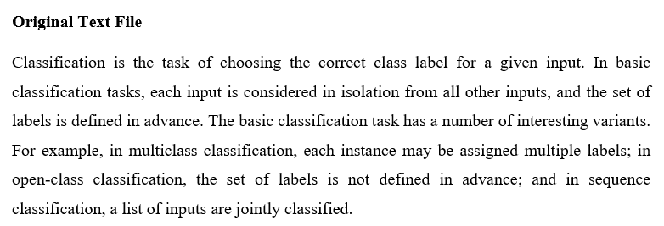

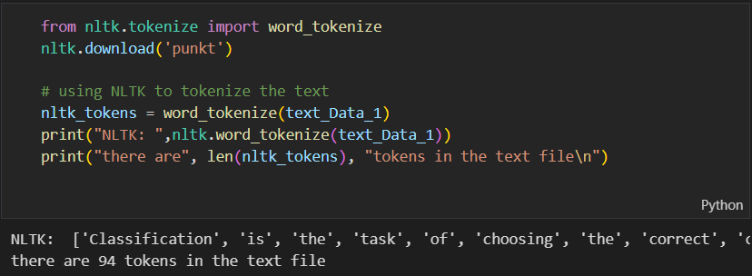

Figure : NLTK

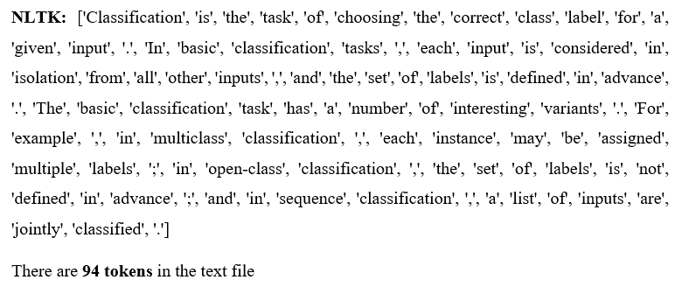

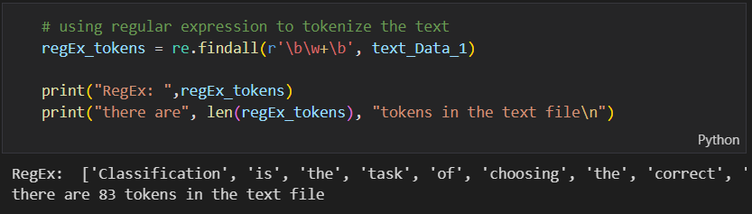

Figure : Regular Expression

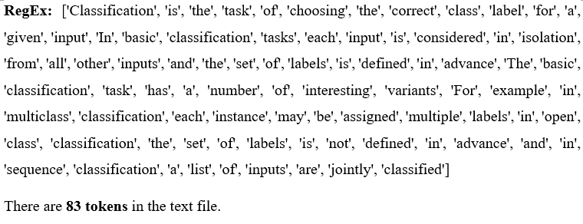

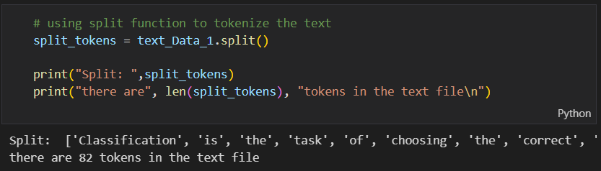

Figure : Split function

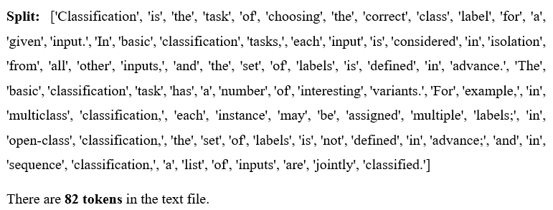

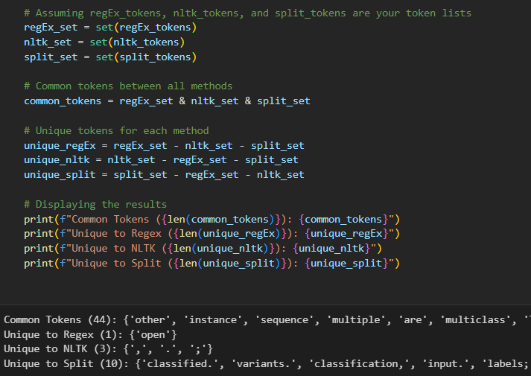

Figure : Unique Tokens

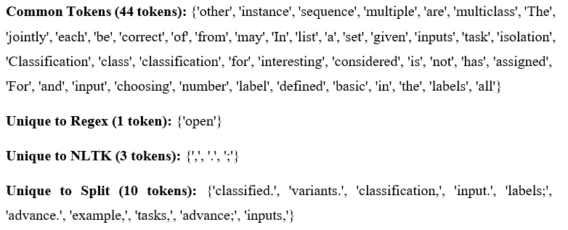

### *Justify the most suitable tokenization operation for text analytics. Support your answer using obtained outputs.*

By performing token count and unique token analysis, the finding shows NTLK is the most suitable tokenization operation as it has the highest number of tokens (94) compared to split (82) and RegEx (83) followed by separating punctuations using 3 unique tokens (",", ".", ";") correctly to avoid noisy data which does not shows in the other two methods. The combination of higher token count and unique token analysis strongly supports NLTK as the best tokenization method.

### *1.3 Demonstrate stop words and punctuations removal and report the output suitably along with the stop words found in the given text corpus.*

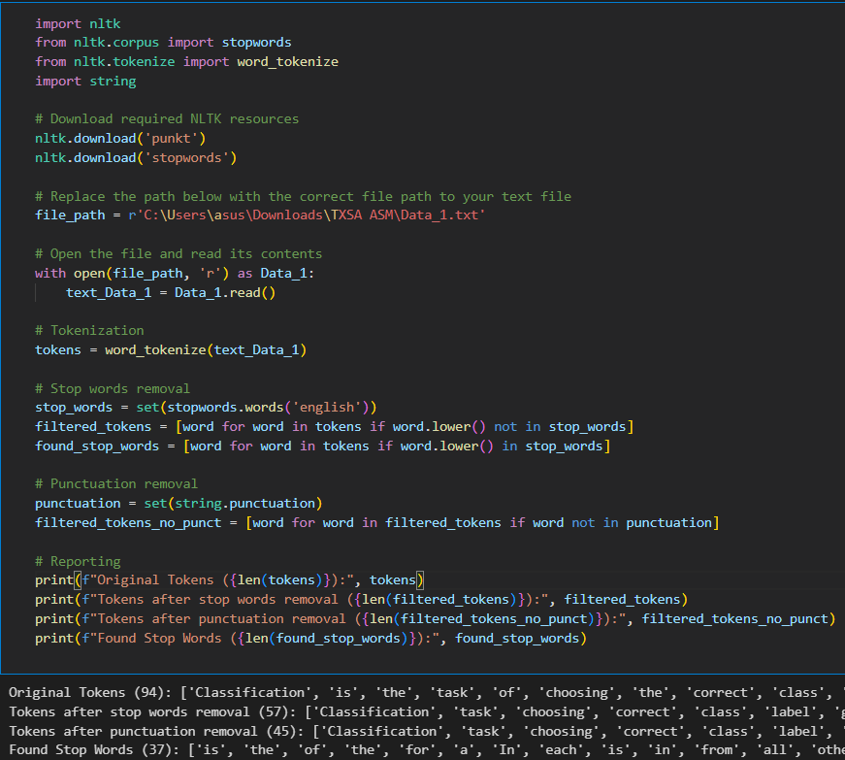

Figure : Stop words and punctuations removal

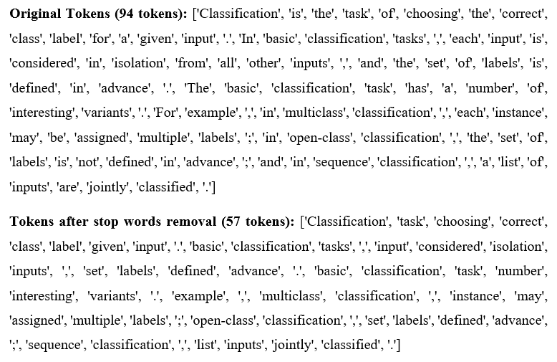

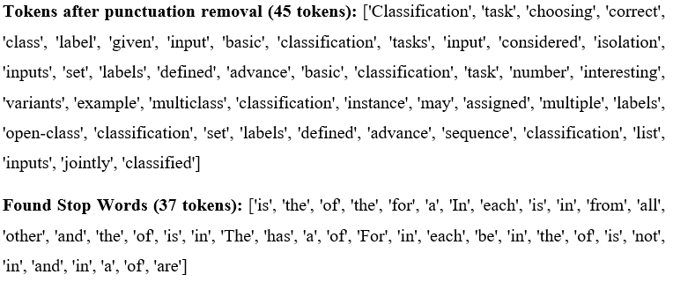

### *1.4 Explain the importance of filtering the stop words and punctuation in text analytics.*

Removing stop words and punctuations can help reduce the noise in textual data, making it more manageable and faster to process. This allows for more accurate analysis and interpretation by removing words that do not carry much meaning. Therefore, it helps to increase the accuracy of machine learning models by improving the performance of natural language processing algorithms.

## Q2 Form word stemming [Soo Jiun Guan – TP068687]

### *2.1 Explain the importance of stemming in text analytics*

Text analytics aims at gaining meaningful insights from unstructured data through various techniques and methodologies. (Top Text Analytics Companies, n.d.). However, grammatical, inflectional, and context variability in text inherently introduces noise to make analysis difficult and may lead to false negatives (Gupta, 2022).

Stemming provides a key role in addressing these challenges by reducing words to their root or base forms, effectively collapsing variations into a single entity (Saumyab, 2024). This reduction in datasets reduces redundancy, enabling algorithms to more easily spot patterns and relationships (Moral et al., 2014). Moreover, stemming enhances computational efficiency and speeds up the process for more accurate analytics by reducing vocabulary dimensions.

Furthermore, its effect can be observed in various tasks. For example, in sentiment analysis, stemming consolidates related terms such as "happy" and "happiness" to make the trends of sentiment more understandable (Stemming, n.d.). For text classification, it removes the noise by regularizing the forms of words, which allows classifiers to focus on the main concepts and thus provide more accurate results (Rianto et al., 2021). In a nutshell, it reinforces analytical efficiency, reduces data complexity, and supports meaningful insights from textual data when used thoughtfully.

### *2.2 Demonstrate word stemming using Regular Expression, Porter Stemmer and Lancaster Stemmer and report the output*

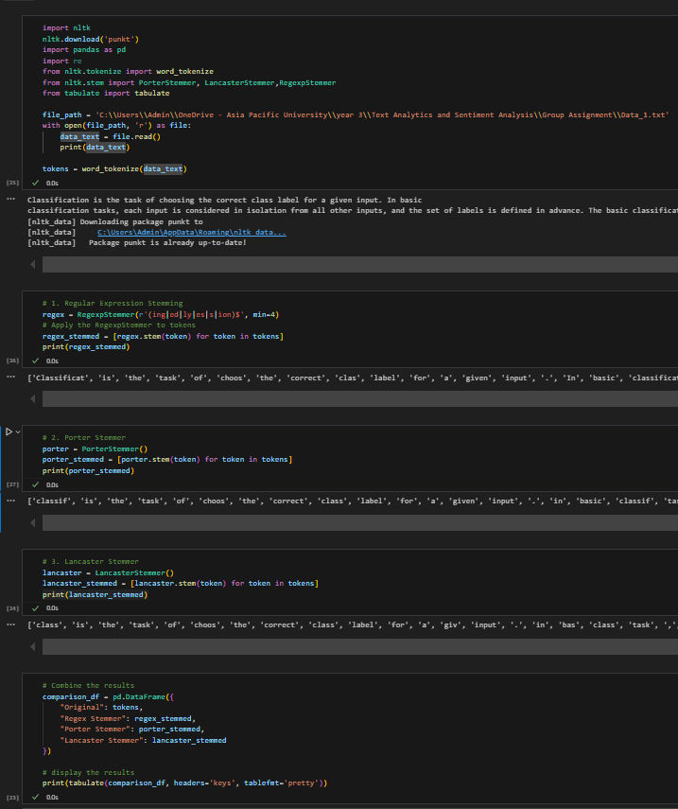

Figure : Stemming algorithms

The code snippet above demonstrates the application of three stemming methods. It begins by tokenizing the input text, followed by simplifying the tokens using each stemming method. Finally, the results are presented in a structured table, highlighting the differences in outputs produced by each method.

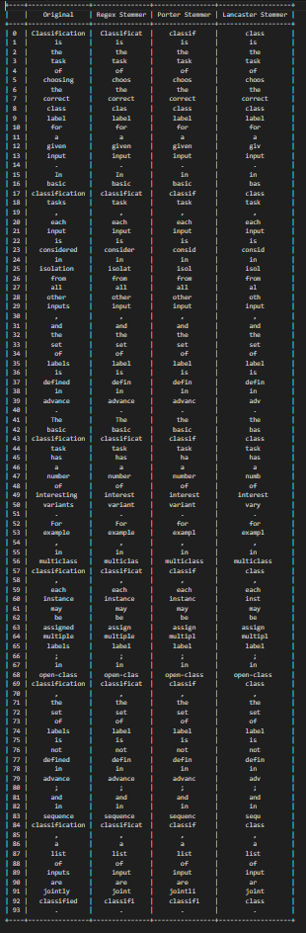

Figure : Output of stemming algorithms

### *2.3 Explain the differences among Regular Expression stemmer, Porter Stemmer and Lancaster Stemmer using the obtained output*

From the output, there are clearly different approaches between the stemmers. The Regex Stemmer relies on user-defined patterns, as shown in "classification" → "classificat", offering simplicity and customization but limited to predefined suffixes. The Porter Stemmer provides a balanced reduction, seen in "classification" → "classif", making it effective for general NLP tasks, though it occasionally over- or under-stems. While the Lancaster Stemmer is much more aggressive, as can be seen in "classification" → "class", it favours brevity, usually at the cost of interpretability. Each of these approaches serves different needs and focuses on different priorities.

## Q3 Form Parts of Speech (POS) Taggers & Syntactic Analysers [Aidan Chang Wai Yue – TP063411]

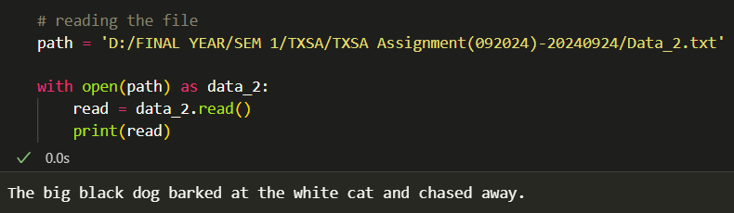

Figure : Data_2.txt’s content.

This section demonstrates POS tagging with NLTK, TextBlob, and Regular Expression taggers, highlighting output variations and sentence structure analysis.

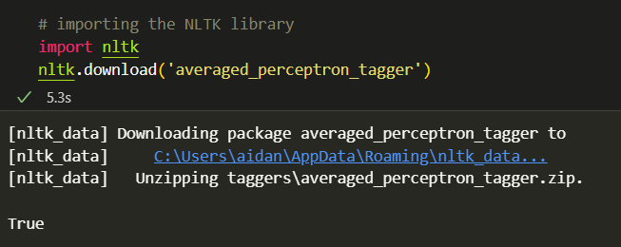

Figure : Installing the NLTK library.

NLTK library will be installed for taggers and parse trees where the pretrained ‘averaged_perceptron_tagger’ model will label words with their parts of speech (Thing Thing et al., 2022)

### *3.1 Demonstrate POS tagging using NLTK POS tagger, TextBlob POS tagger and the Regular Expression tagger and report the output*

**NLTK POS Tagger**

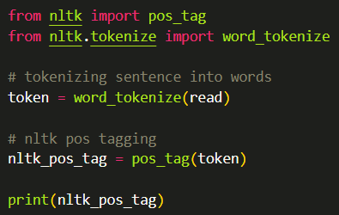

Figure : POS tagging with NLTK’s POS tagger.

To label the POS of the Data_2 sentence, NLTK classes are imported. The 'word_tokenize' function is used to split the sentence into words, then each word is tagged with 'pos_tag' and printed.

**NLTK POS Tagging Result**

|  |
| --- |
|  |

**TextBlob POS Tagger**

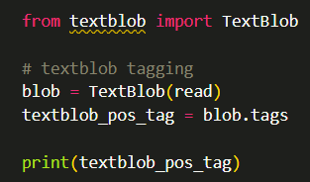

Figure : POS tagging with TextBlob.

The 'TextBlob' class is imported from the textblob library, which offers text processing, sentiment analysis and POS tagging. The sentence is then stored in the 'blob' object and the results are printed.

**TextBlob POS Tagging Result**

|  |
| --- |
|  |

**Regular Expression Tagger**

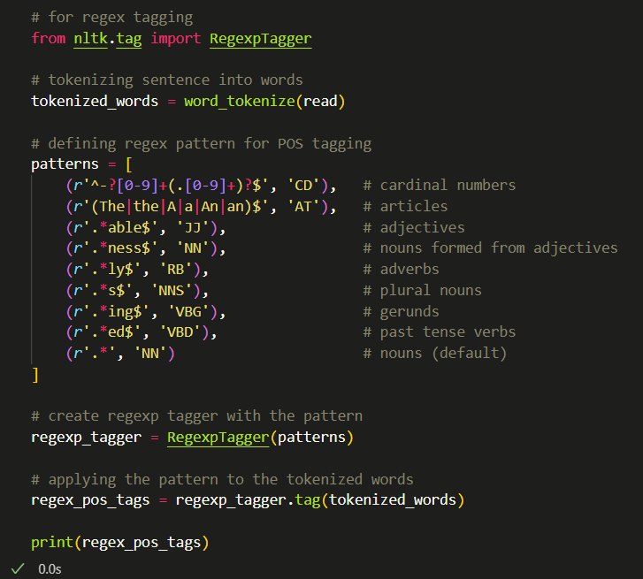

Figure : POS Tagging with Regular Expression.

The ‘RegexpTagger’ class is utilized for POS tagging through defined regular expressions. After tokenizing the sentence into ‘tokenized_words’, explicit patterns are created for tagging, matching adjectives ending with “able” and adverbs with “ly”. A RegexpTagger object tags the tokenized words, storing results in ‘regex_pos_tags’, which is then printed.

**Regular Expression Tagging Result**

|  |
| --- |
|  |

### *3.2 Explain the differences of the POS taggers using the output obtained in the above question*

NLTK's POS Tagger employs a pre-trained model from the Google News Dataset, ensuring accuracy and flexibility but may slow with larger datasets (NLTK, n.d.). TextBlob is the simplest, ideal for beginners, but its dependency on external libraries can complicate management (TextBlob Reviews, Pricing and Features - 2024, n.d.). RegexpTagger requires regex expertise for custom tagging, making it less user-friendly but highly customizable. Each tagger offers distinct pros and cons, suiting diverse user needs.

### *3.3 Draw possible parse trees for the given sentence using suitable python codes and report the output along with the code*

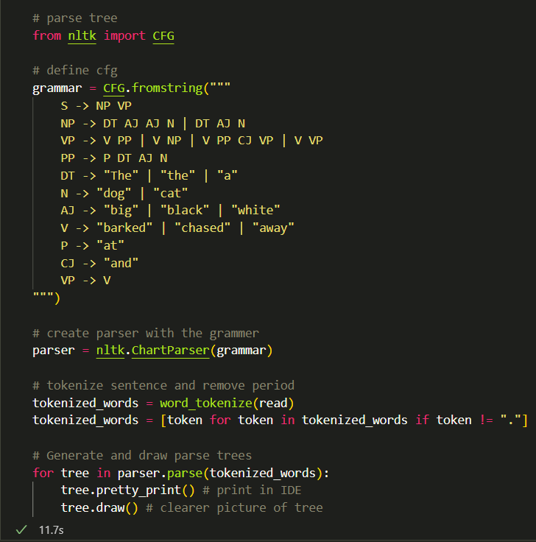

Figure : Parse tree.

The CFG class from NLTK is imported to define grammar rules for structuring sentences and create the parse trees.

The rules outlined specify sentence structure: a sentence (S) is a noun phrase (NP) followed by a verb phrase (VP). Noun phrases can include a determiner (DT), adjectives (AJ), and a noun (N). Verb phrases may include verbs (V), prepositional phrases (PP), and conjunctions. Terminal symbols specify the actual word forms used.

A parser is created using ‘ChartParser’ for CFG-based sentence parsing. The sentence is tokenized without a period. Parse trees are displayed with ‘tree.pretty_print()’ and ‘tree.draw()’ in the IDE and graphical format respectively.

**Output from IDE**

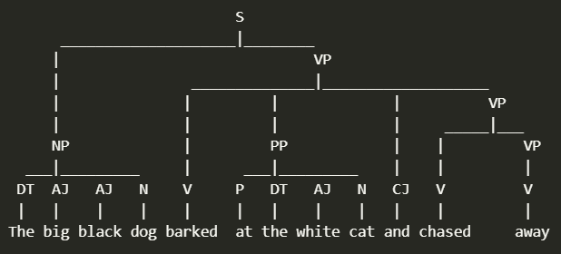

Figure : Parse tree from IDE

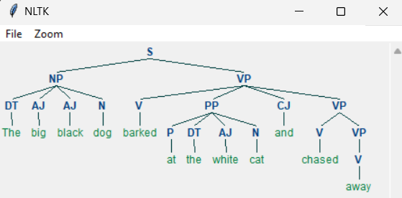

Figure : Parse tree from NLTK Graphic.

The output illustrates the sentence's division into speech parts, adhering to CFG rules. It begins with the sentence (S), followed by noun phrase (NP) and verb phrase (VP), extending to elements like determiners (DT), adjectives (AJ), and more. NLTK's graphical output surpasses IDE's clarity and accuracy.

## Q4 Work on sentence probabilities [Soong Yau Joe – TP068977]

### *4.1 Compute manually the sentences probabilities using the unsmoothed bigram model.*

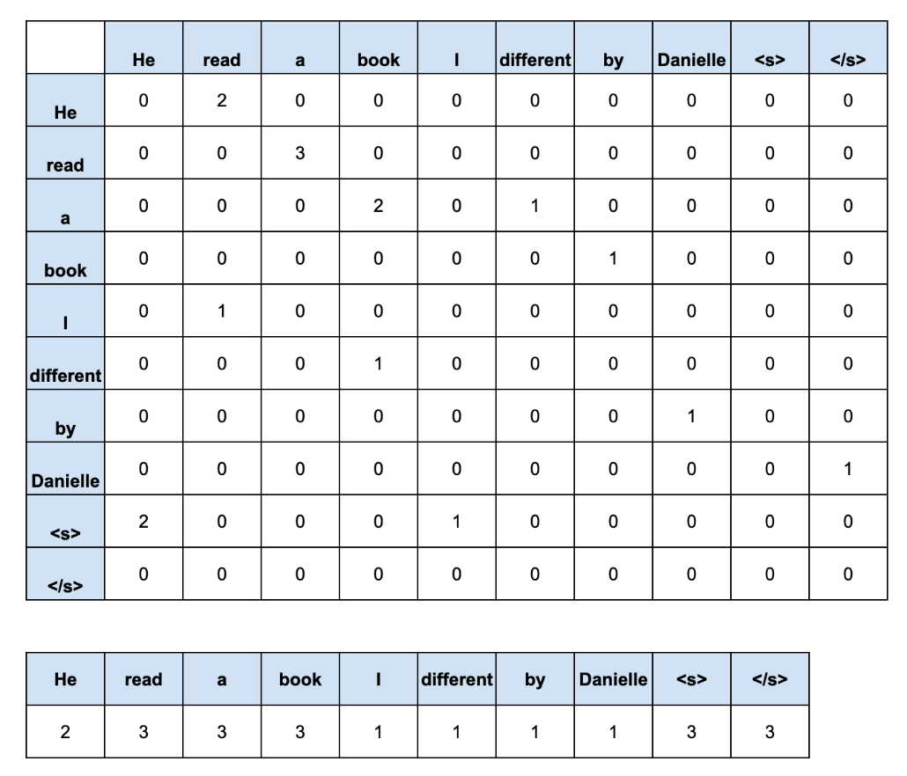

Figure : Table of Frequencies of Occurrence of Two Subsequent Words and

Table of Frequencies for Each Word Occurrence in The Entire Sentence

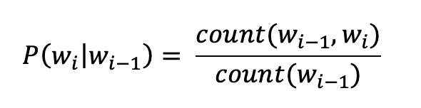

Figure : Formula to Calculate Probabilities in Unsmoothed Bigram Model

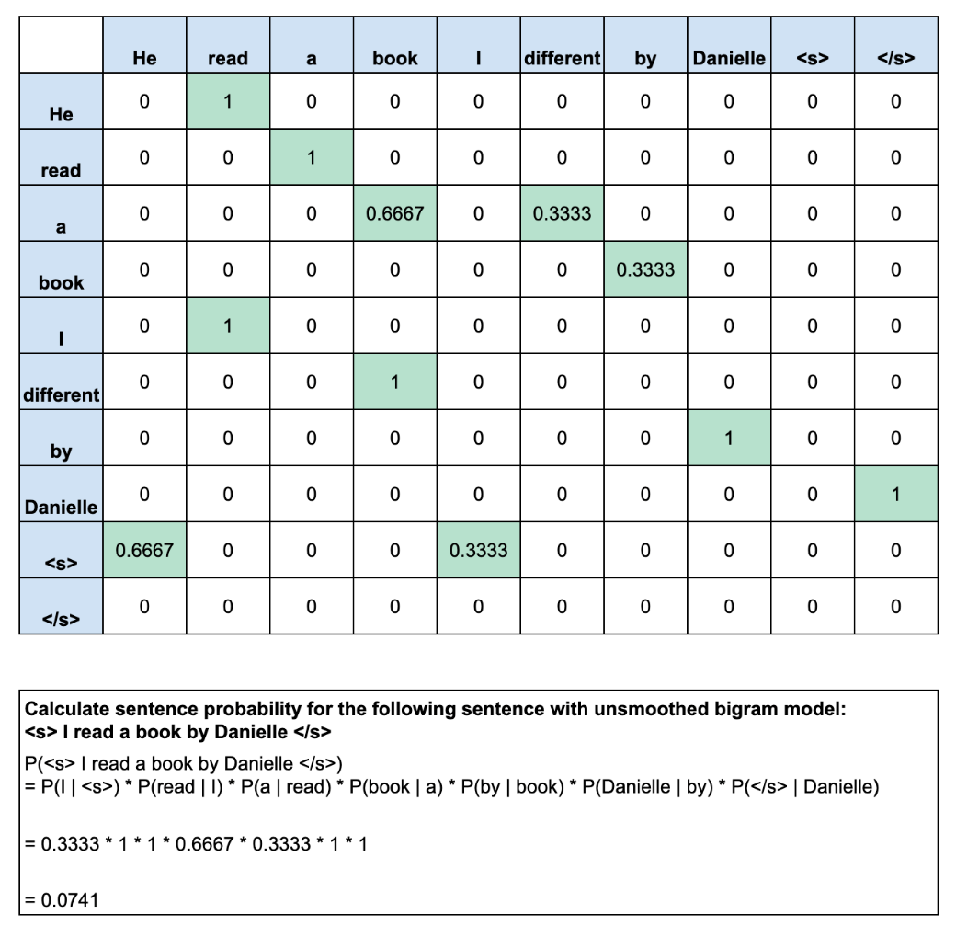

Figure : Manual Solution for Unsmoothed Bigram Model Using Google Sheet

### *4.2 Compute manually the sentences probabilities using the smoothed bigram model.*

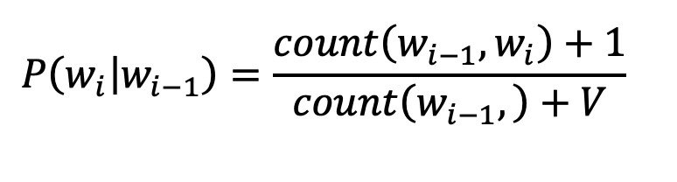

Figure : Formula to Calculate Smoothed Bigram Model

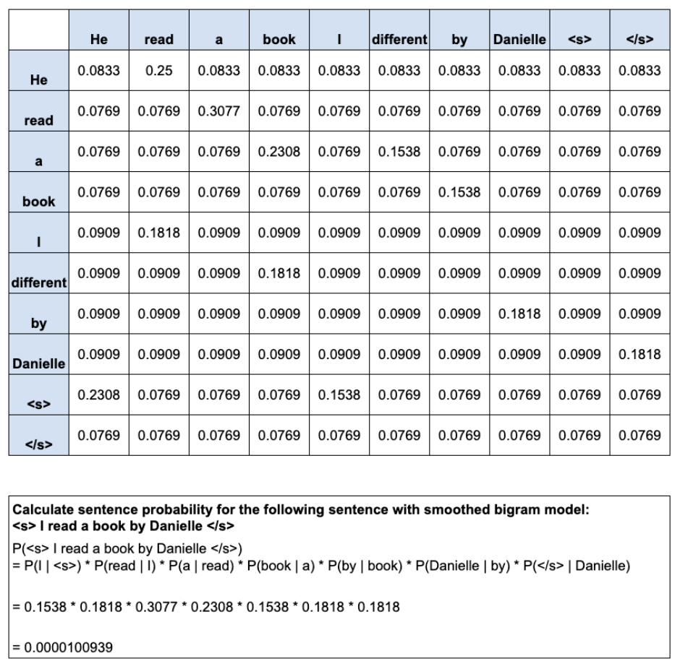

Figure : Manual Solution for Smoothed Bigram Model Using Google Sheet

### *4.3 Implement in python using both unsmoothed and smoothed bigram language models and report the respective sentence probabilities.*

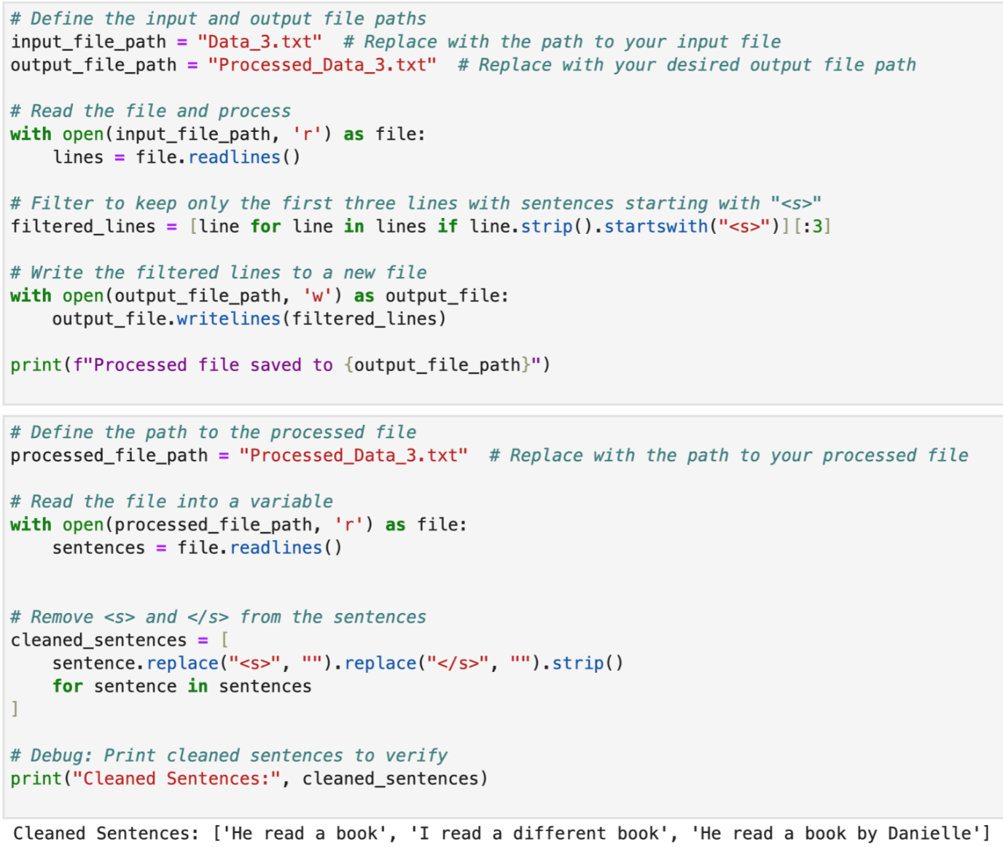

Figure : Code and Output of Preprocess the Sentences in the Text File

Some necessary cleaning is being done during importing the text data into a variable which include filtering out the sentence that is going to be train in the model as well as removing the existed padding on the sentences which are <s> and </s> to enable padding function to take place properly during the model training.

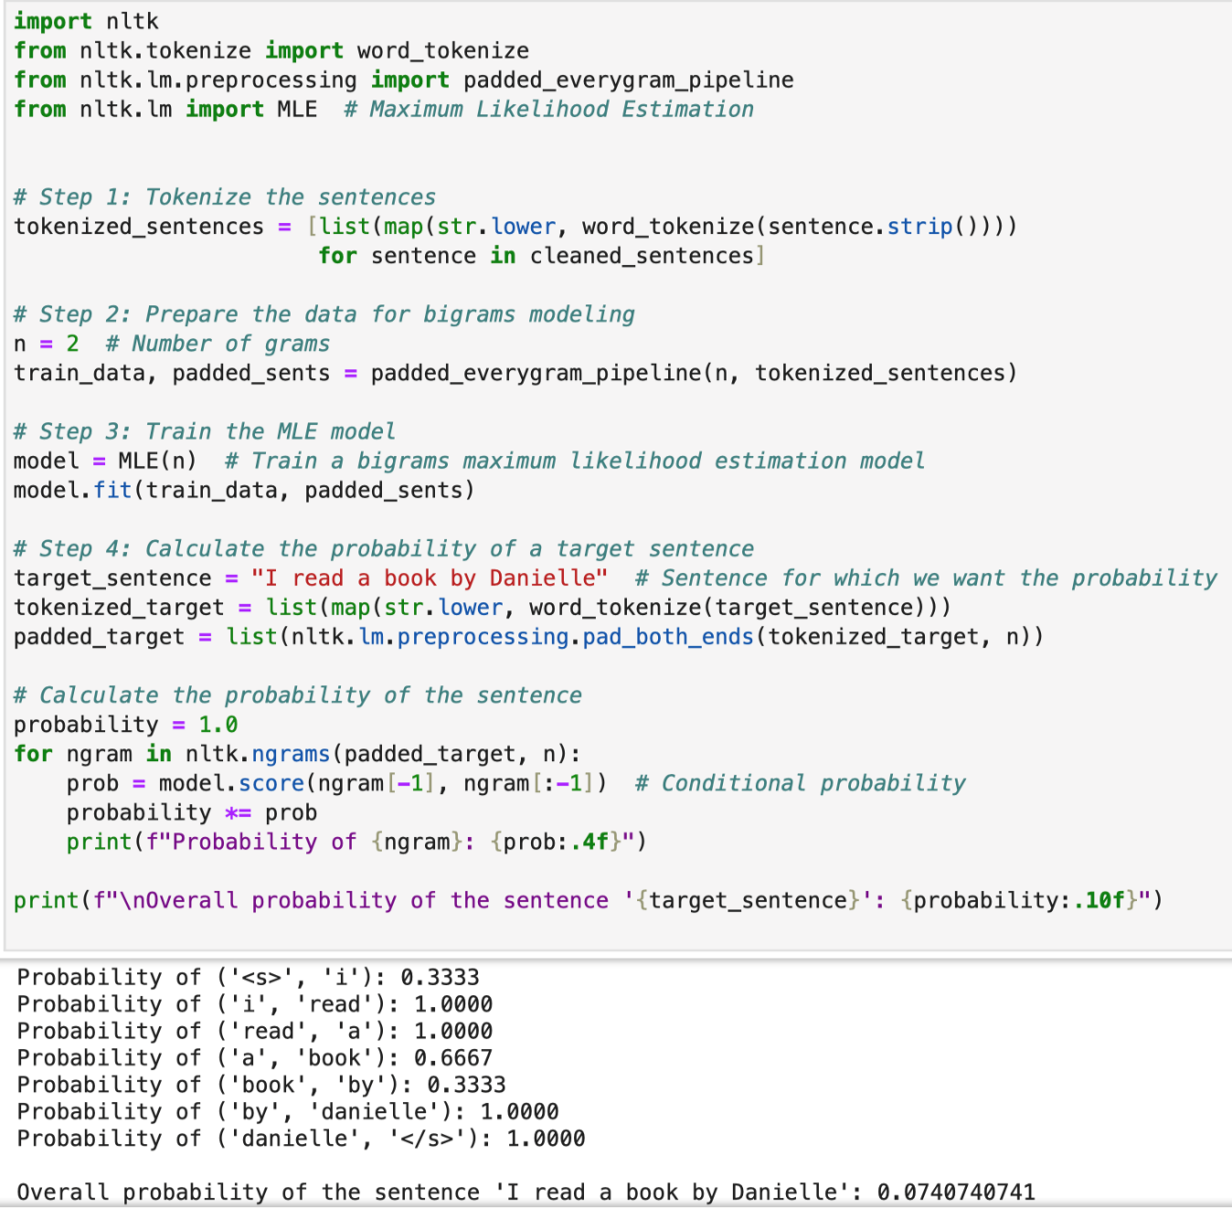

Figure : Code and Output of Unsmooth Bigram

The probability obtained by the unsmooth bigram model for the selected sentence is nearly the same as the result calculated manually which is around 0.0741.

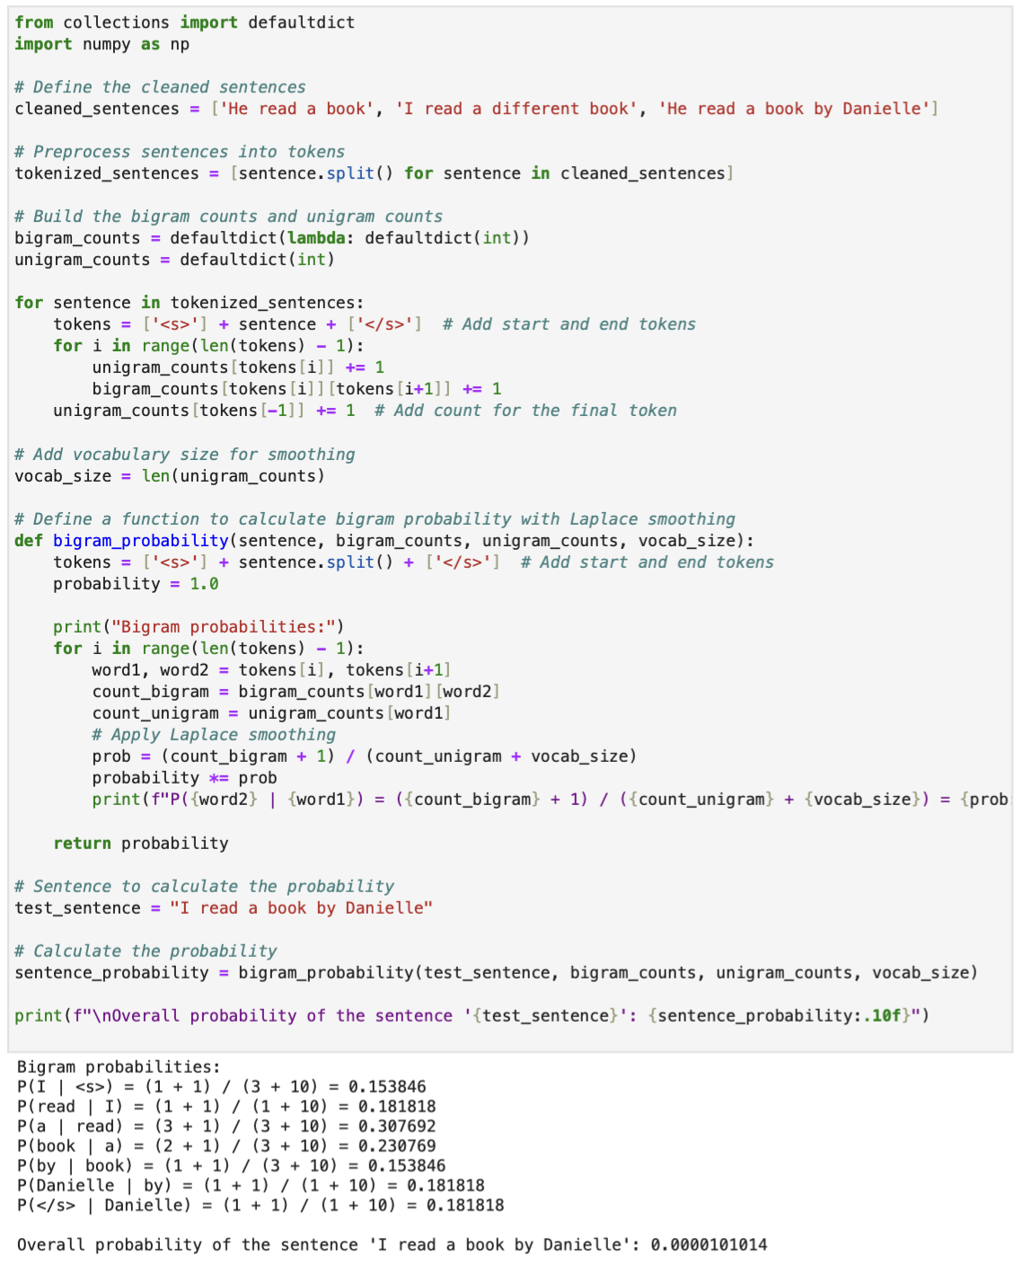

Figure : Code and Output of Smoothed Bigram Model Using Laplace Smoothing

The result obtained for the smoothed bigram model for the sentence’s probability is approximately the same as the result calculated manually which is around 0.00001010.

# PART B

## Introduction

Spam detection is one of the main challenges in modern communication systems that deteriorates user experiences and creates huge security risks (Vijayasekaran & Rosi, 2018). These rapid growing messages ranging from irrelevant advertisements to phishing attempts has raised the needs of spam classification and filtering. Without such mechanisms in place, users are predisposed to fraud activities, receive reduced productivity, and have bad experiences with communication services.

The medium size text-based dataset used in this study was obtained from Kaggle, consisting of 20,348 labelled text entries categorized as either “spam” or “ham” which is considered sufficient diversity for spam classification model building.

## Literature Review

Spam detection has been one of the key research areas because of the increasing number of unsolicited messages on digital communication platforms. Most studies emphasize the need to develop strong classification systems that can help in overcoming this challenge. Naïve Bayes has emerged as a suitable method for spam filtering, especially in an environment where computational efficiency is a major concern (Vijayasekaran and Rosi, 2018). Similarly, Support Vector Machines (SVMs) have been shown to have high accuracy in detecting spam, especially when it is optimized for a particular dataset and feature set (Tekerek, 2018). Building on this, while both Random Forest and Gradient Boosting were similarly effective, their recall of spam was sufficiently lower that its application would be better where high precision rather than recall is preferred (Airlangga, 2024). These findings combined guarantee the feasibility and effectiveness of these models in spam detection.

Preprocessing and feature extraction are crucial parts of any spam detection system. The use of techniques such as Term Frequency-Inverse Document Frequency (TF-IDF) and Bag-of-Words (BoW) are also helpful in the process of transforming unstructured text into structured data for analysis (Abid et al., 2022). Besides this, handling dataset imbalance through oversampling and under sampling tends to boost the performance of the classification model in terms of accuracy and reliability on spam detection.

However, it is still very hard to keep pace with the ever-evolving techniques used by spammers. Since spam is dynamic in nature, with features such as obfuscation and randomized patterns, there's a demand for evolving detection systems that can proliferate with changes (Amayri and Bouguila, 2010). Furthermore, the tension between high recall in spam detection and correct classification of legitimate messages makes innovation in spam detection technologies a never-ending need.

The reviews of the existing studies underline the efficiency of models such as Naïve Bayes, SVMs, and ensemble methods, as well as stressing the need for robust preprocessing techniques. As spammers adopt newer tactics to spam, the need for creative and adaptable detection systems becomes all the more important, necessitating continuous research and development to tune these systems to enhance security and reliability in digital communication platforms.

## Exploratory Data Analysis (EDA) and Preprocessing

### Import and Display Basic Information of Data

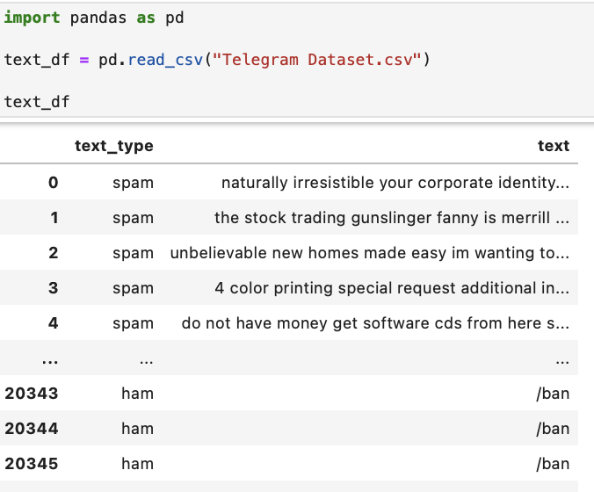

Figure : Code and Output of Importing Dataset

First, a telegram dataset had been loaded into python using pandas. This dataset has two columns which is **text_type** and **text**. **Text_type column** had spam and ham while **text** **column** contains spam messages.

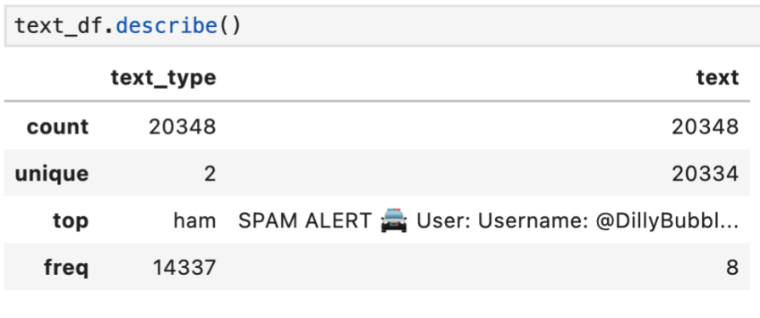

Figure : Code and Output to Describe the Basic Info of Variable

By using text_df.describe() function, it shows that there are **20,348 entries** in the text_type column, **2 unique values** (spam and ham). The most frequent value is “ham” which appears **14,337 times**. For text columns, most messages are unique, but 8 messages are repeated.

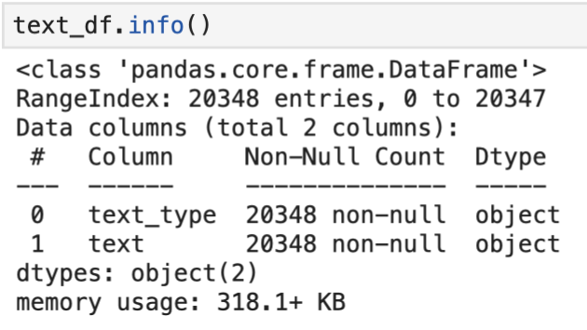

Figure : Code and Output to Show the Type of Variable for each Field

By using text_df.info() function, it provides the overview of data frame structure. There are **20,348 rows,** **2 columns** which are text_type and text contain **non-null values** and messages and they are being set default as object type by pandas which requires necessary of type conversion.

### Change Variable Type

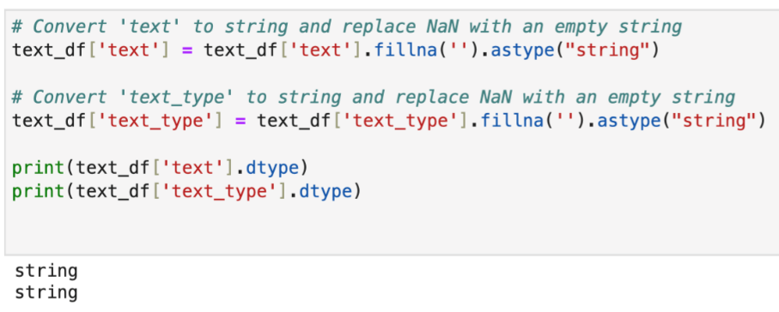

Figure : Code and Output of Converting Variables Type

Any **missing values** in the text and text_type columns were replaced with an empty string ' '. Both columns had been **converted to the string data** type and the reason is just to ease the process of handling and preprocessing the text data.

### Find and Remove Duplicate Rows

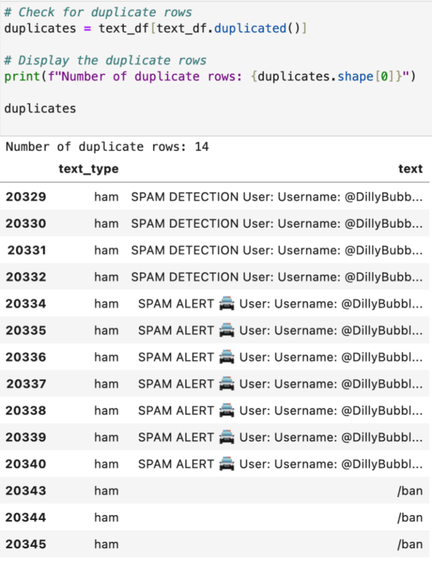

Figure : Code and Output to Check for Duplicate

**Duplicate rows** were identified in the DataFrame using text_df_duplicated() and store in the duplicate variable. It has been found out that there are **14 rows of duplication** occurring on the dataset which has to be handled.

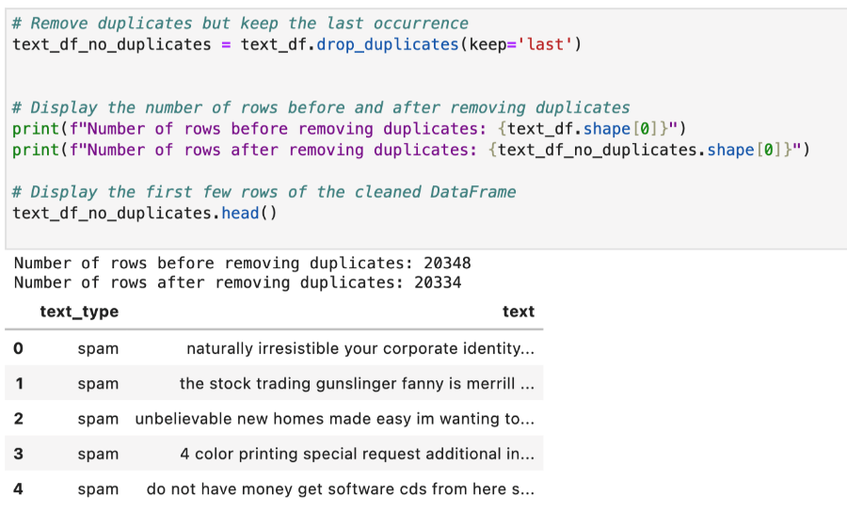

Figure : Code and Output of Removing Duplicates

Duplicate rows were removed from the DataFrame using text_df_drop_duplicates, retaining only one of each duplicate row, decreasing the number of rows from 20348 to 20334 after deletion.

### Words Exploration

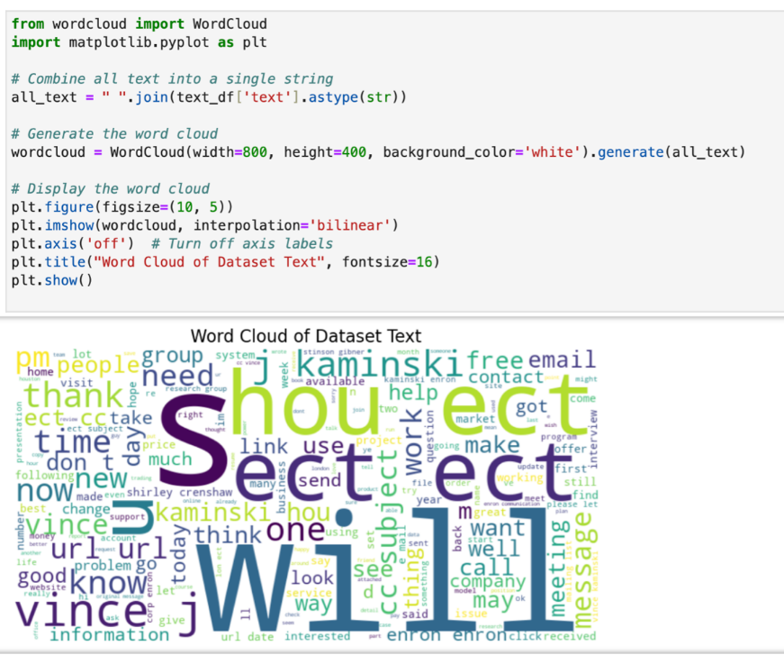

Figure : Code and Output of Word Cloud Before Preprocess

Based on the word cloud diagram, it shows that words like "will", "Sect", and "Shout" are the most common as they are taking large space which is an indication of high frequency. There are other words that’s worth further investigating such as ‘url’, ‘link’, ‘email’, ‘contact’.

### Explore and Handle URL Related Words in Text

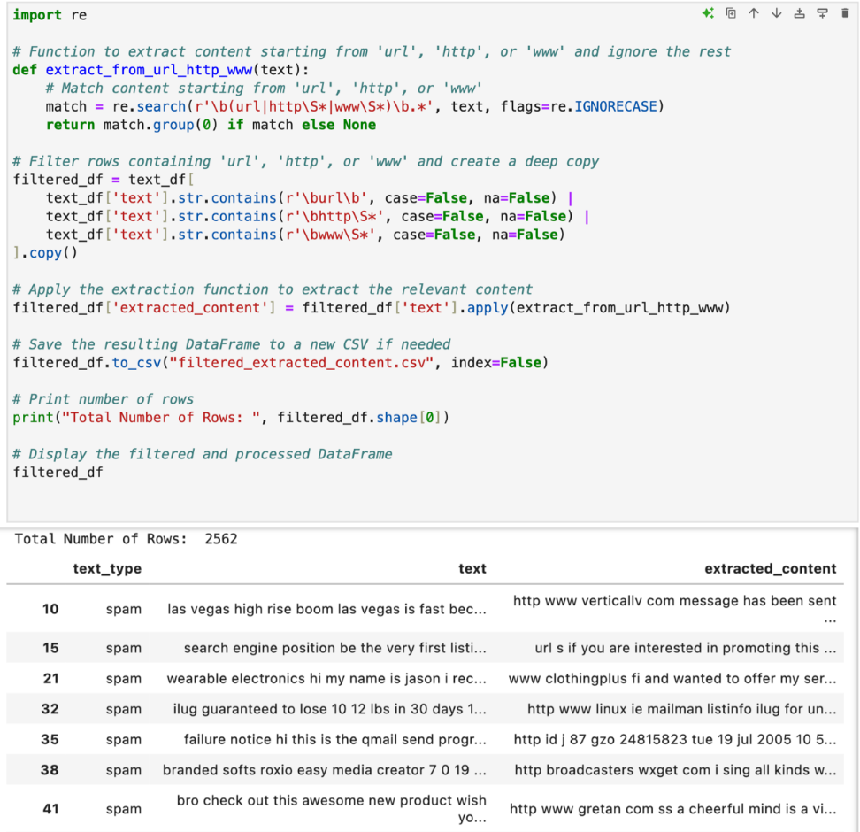

Figure : Code and Output for Extract and Discover the Pattern of Link Related Words

There are 2562 rows being discovered after extracting keywords related to URL such as "http," "www," and "url" followed by filtering out the rows containing them by the help of regular expression.

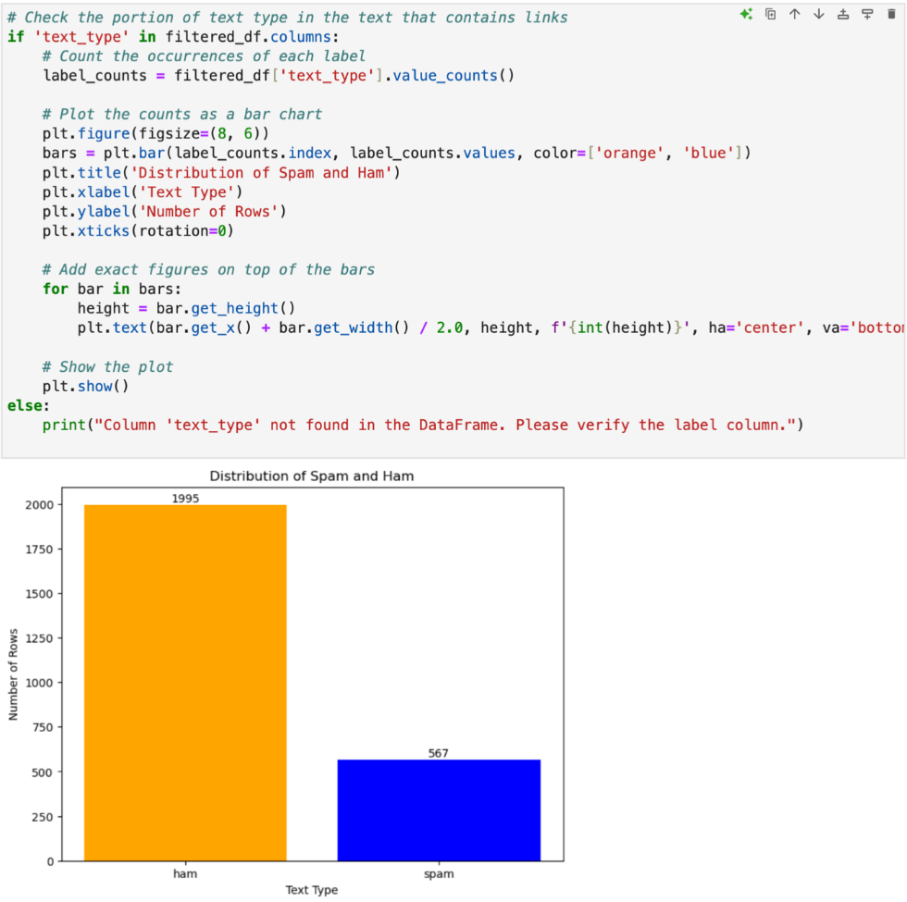

Figure : Code and Output of Displaying the Portion of Spam and Ham in Text That Contains Links

There are majority of “ham” messages lies within the dataset that contains links which indicates the unnecessity in exploring the links that contribute to spam issue.

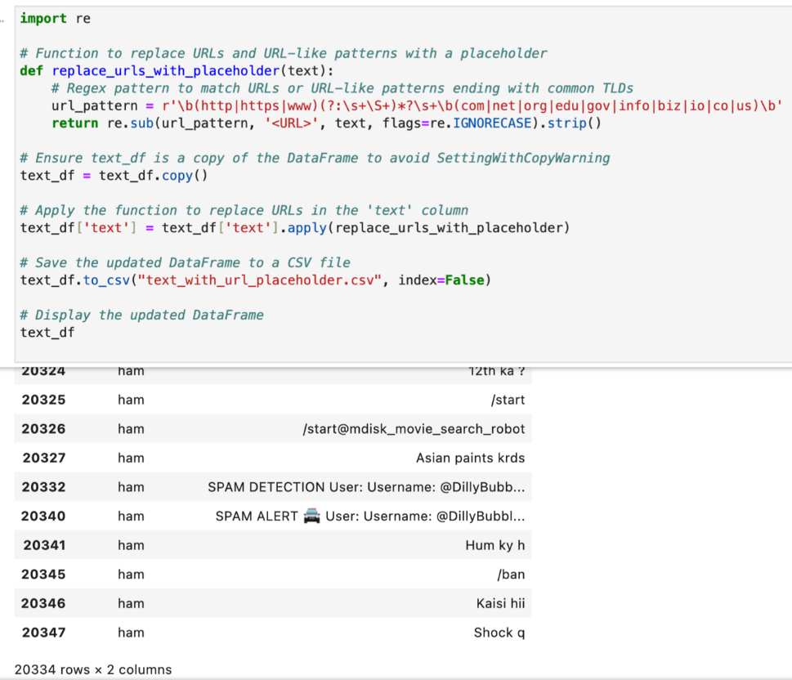

Figure : Code and Output of Replacing Link with Tag



Figure : Sample Sentence Before Replacing by Tag



Figure : Sample Sentence After Replacing by Tag

The link is being replaced with tag which is **<URL>** since the link information are not a main concern because the insignificant portion of them exist in the records.

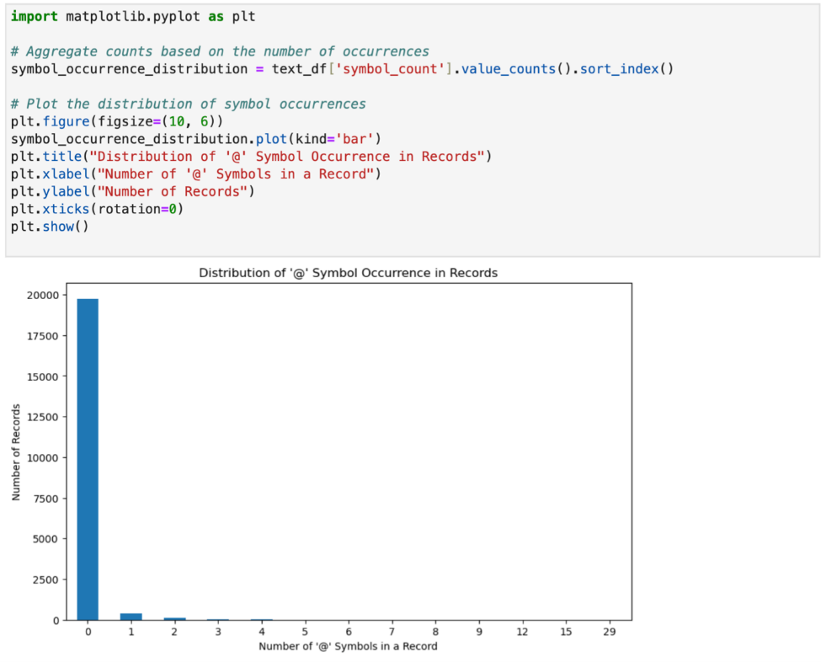

Figure : Plot of Frequency Bar Chart Against the number of '@' Symbols in a Record

The @ symbol has been proved to be unsignificant and could be proceed for deletion based on the extremely low occurrence among the records shown in the bar chart.

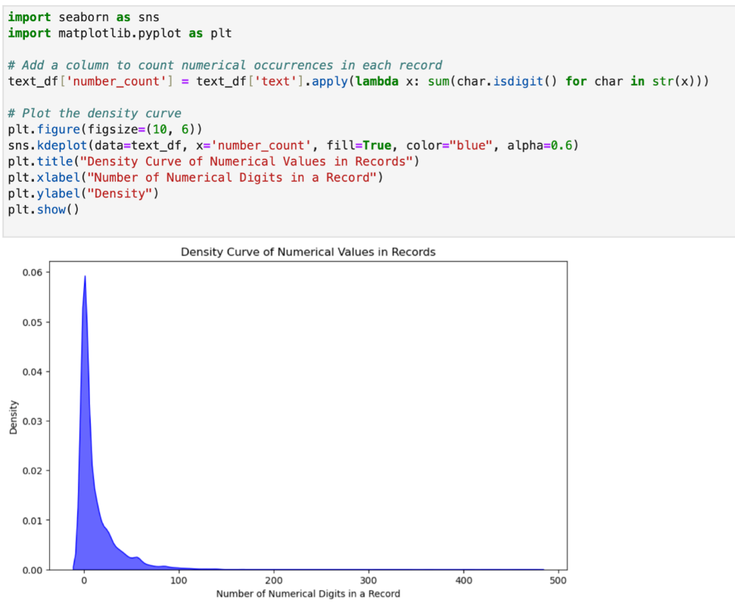

Figure : Density Curve of Number of Numerical Value in a Text

The significant amount non-numerical value in the dataset is shown on the density plot with peak density on the ‘0’ number of digits in records, showing it is acceptable to remove numbers from the sentences.

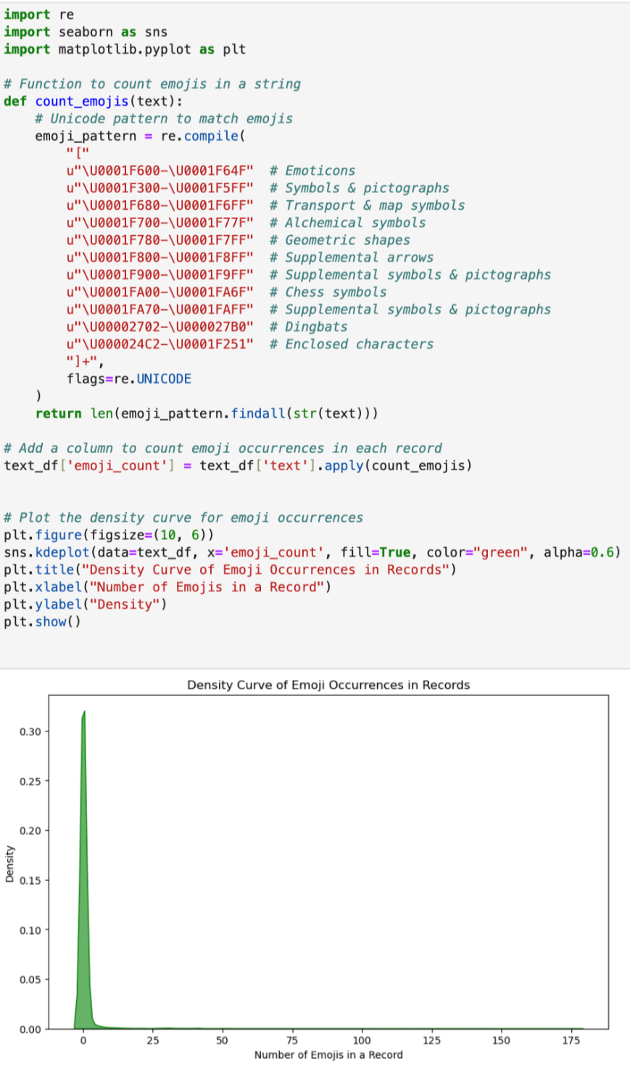

Figure : Density Plot to Show the Likelihood of Emoji Present in a Text

The scarce amount of emoji occurrence in the record which has shown in the density plot has become a proof to remove them from the records.

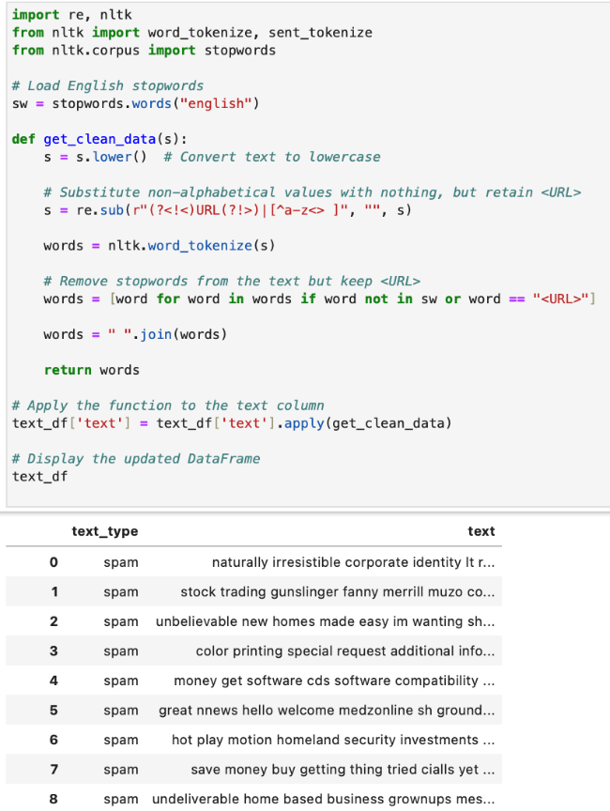

Figure : Code and Output of Preprocessing the Sentence

Text cleaning process was then applied to text column by **converting text to lowercase** and removing unwanted characters. Then, **non-alphabetical** characters that don’t add value to text analysis but **retain <URL>** were eliminated**.** Lastly, **stopwords** (e.g., "the," "is") are filtered out.

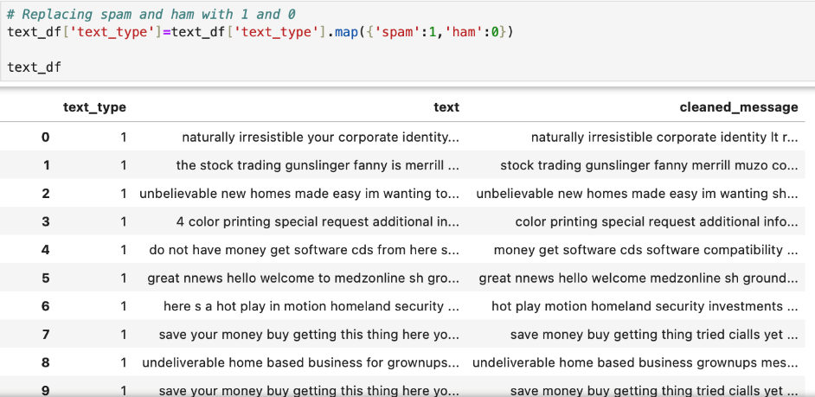

Figure : Code and Output to Replace String with Value

“spam” and “ham” under the test_type has been converted into 1 and 0 for a more simple use purpose.

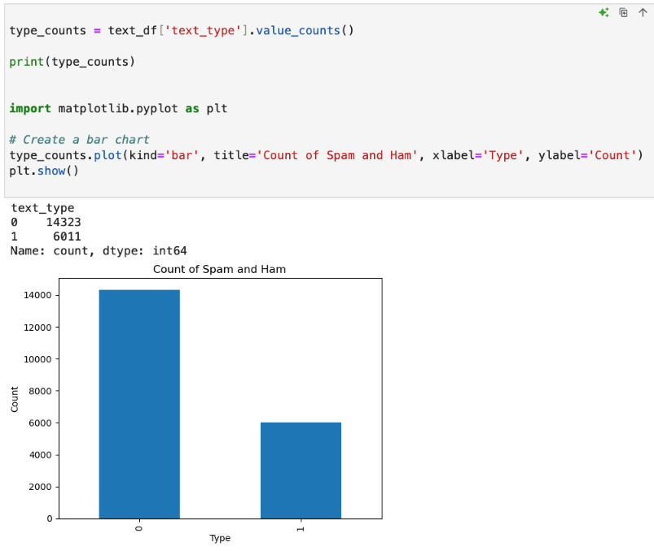

Figure : Code and Graph to Explore Counts of Spam and Ham

The significant unbalance count between ‘spam’ and ‘ham’ classes which are 6011 and 14323 has showed the importance in performing class balancing techniques afterwards.

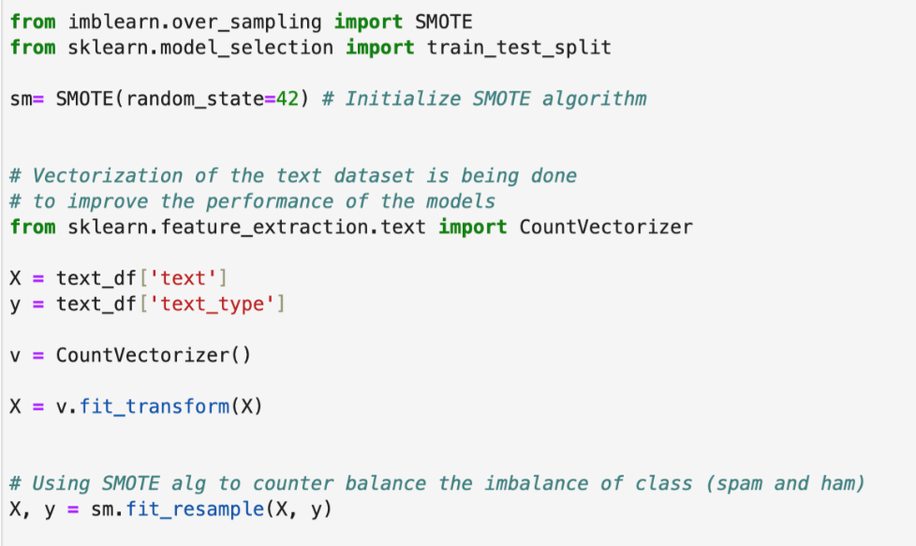

Figure : Code to Vectorize Text and Balance the Class Distribution

Synthetic Minority Oversampling Technique (SMOTE)algorithmwas usedto handle class imbalance in a dataset. **CountVectorizer()** then transforms the raw text into a sparse matrix of token counts, converting text into a format suitable for machine learning algorithms. It generates **synthetic samples** for the minority class (spam) to balance the dataset.

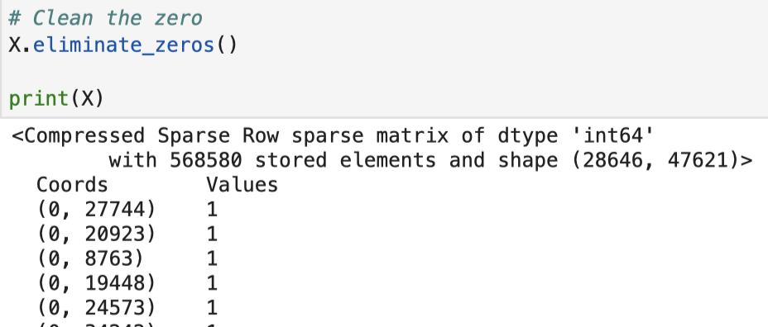

Figure : Output of X After Pre-processed by SMOTE Algorithm

The code above is to ensure the occurrence ‘Values’ are all greater than 0. The information that stores in the variable X are having a coordinate along with a respective value in which the x coordinate is the nth sentence followed by the y coordinate which is a unique number of a particular word followed by the value of occurrence of that word in the sentence. For instance, (0, 27744) with 1 as the value means that the word labelled as 27744 exists 1 time in the first sentence.

## Q2 – Base Model Building

### 2.1 Multinomial Naïve Bayes (MNB) Classifier

Multinomial Naive Bayes (MNB) model is being known as an effective algorithm for text classification tasks, especially when dealing with discrete data like word counts (Singh et al., 2019). MNB model assumes that the word frequencies in the dataset follow the trends of multinomial distribution, which makes it particularly unique and useful for text-based applications and it is commonly being used in areas such as spam detection, sentiment analysis, news categorization, and fraud detection due to its ability to handle high-dimensional, sparse textual data with efficient result in terms of accuracy (Sharma & Singh, 2016).

From a technical standpoint, MNB operates by estimating the probabilities of features like word occurrences and conditioned on a class label, with the assumption of feature independence in which it helps in reducing the computational complexity and enables the model to handle ginormous dataset in an efficiency manner (Bermejo et al., 2010). By relying on the multinomial distribution and treating word frequencies as primary features, MNB identifies patterns in text based on the presence or absence of words. With the help of some necessary preprocessing techniques such as stop-word removal, stemming, and feature selection could help in enhancing the model's performance at a certain degree, making it suitable for both structured and unstructured textual data (Metsis et al., 2006).

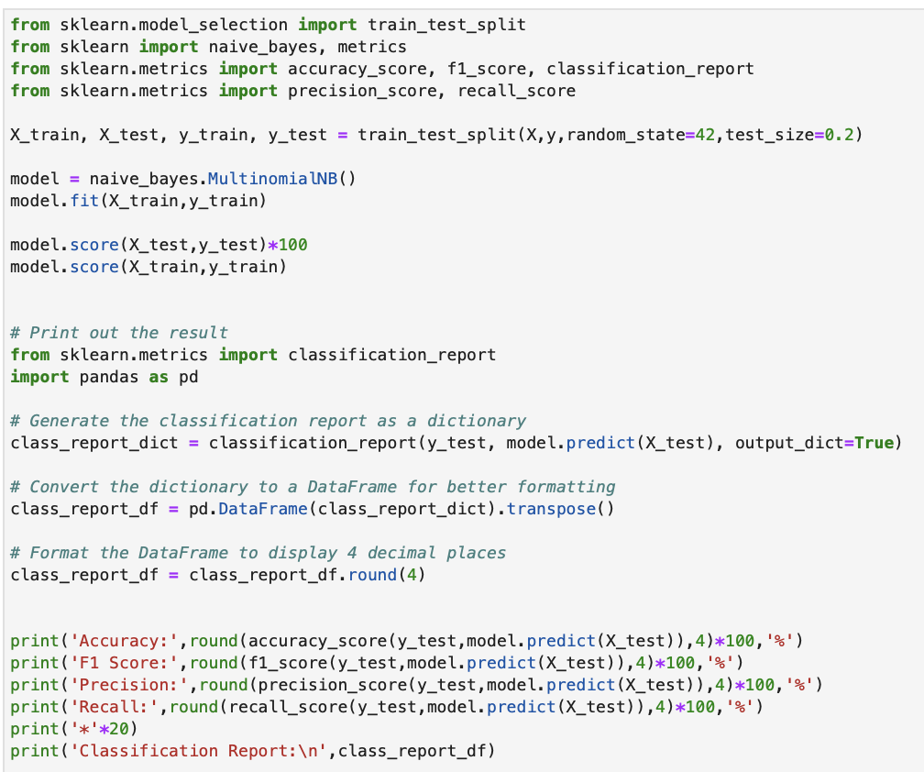

Figure : Code for Building Base Multinomial Naïve Bayes Model

The code above shows the process of building the MNB model which includes splitting of train and test set from the data followed by model building stage.

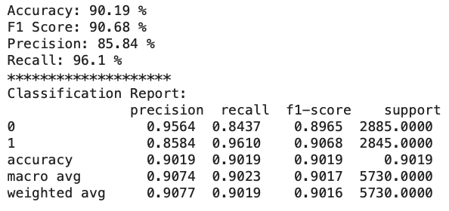

Figure : Result of Base Multinomial Naïve Bayes Model

The result of the base MNB model shows a high accuracy which is 90.19% and 90.68% for the F1 score and this is indicating the model is getting 90.19% of the classification cases correct in the testing stage.

### 2.2 Support Vector Machine (SVM)

Support Vector Machines (SVM) are a very powerful technique in supervised learning for either classification or regression problems (Amarappa & Sathyanarayana, 2014). It works by finding an optimal hyperplane that maximally separates data points from two classes, maximizing the margin and enhancing the robustness of a model that generalizes well on unseen data (Mammone et al., 2009). Whether it is linear or nonlinear, SVMs demonstrate great versatility due to the availability of diverse kernel functions (Bo'riboyevna & Bo'riboyevna, 2023).

SVMs are effective in high-dimensional spaces and perform well with rather small datasets, hence becoming the popular choice of binary classification tasks like spam detection. For such applications, they efficiently classify texts based on features such as TF-IDF while being resistant to overfitting. This capability provides SVMs with the high accuracy and reliability to effectively distinguish spam messages from real ones, focusing on critical data points, known as support vectors (Naeem et al., 2022).

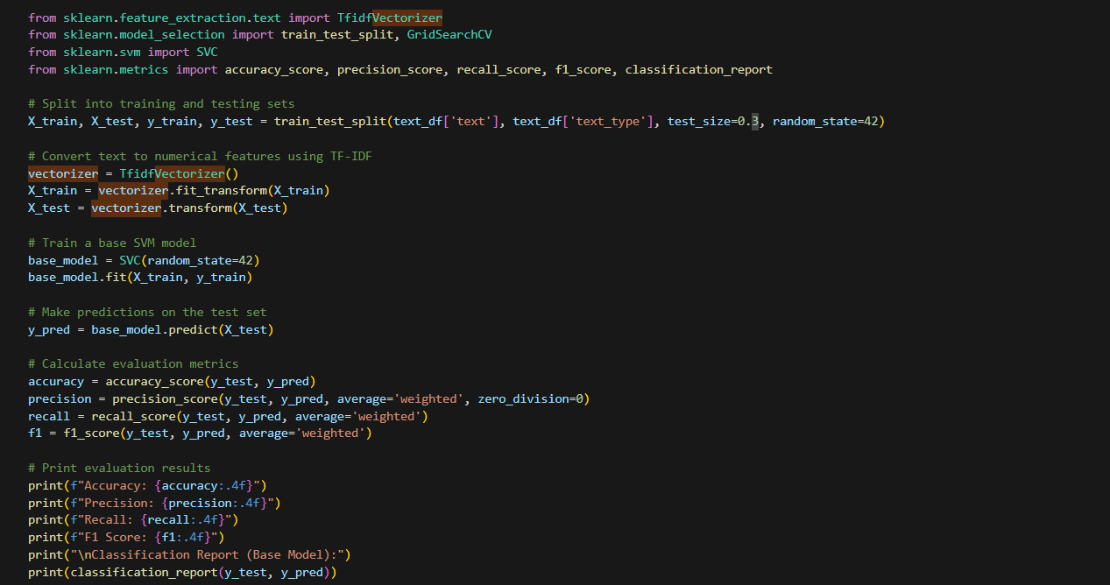

Figure : Base SVM Model

Since Support Vector Classifier (SVC) requires numeric input, text data has to be first transformed into numeric features using TF-IDF vectorization. The dataset is divided into a training set and a test set. Later, the SVC is fitted on the transformed training set. Predictions are then made on the test set, and performance is evaluated by metrics such as accuracy, precision, recall, F1-score, and an overall classification report.

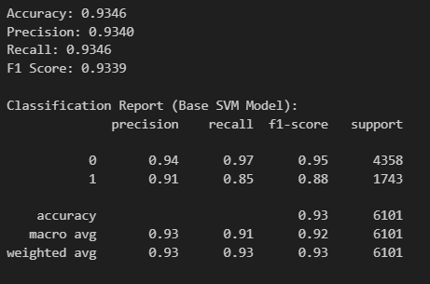

Figure : Performance Metrics of Base SVM Model

The base SVM model achieves **93.46%** accuracy, **93.40%** precision, **93.46%** recall, and an F1 score of **93.39%**. Class '0' (ham message) (precision: **0.94**, recall: **0.97**, F1: **0.95**) performs better compared to class '1' (spam message) (precision: **0.91**, recall: **0.85**, F1: **0.88**). Hyperparameter tuning is able to further enhance these metrics and improve class balance.

### 2.3 Random Forest

Random Forest (RF) is one of the machines learning algorithms, delivering impressive performance across various supervised learning tasks, including classification and regression. Random Forest effectively handles high-dimensional datasets and is widely applied in various fields, such as biomarker identification, finance for credit risk assessment and fraud detection (Learn Statistics Easily, 2024).

RF is highly valued for its ability to handle tabular data and supports tasks such as classification, regression, and feature selection with notable success. For instance, in spam detection, Random Forest algorithms have been shown to effectively identify key predictors of spam by providing feature importance metrics (Bouke et al., 2024). Additionally, they handle class imbalances effectively through their voting mechanism, achieving high accuracy rates and reducing misclassification errors in challenging scenarios, such as accurately distinguishing between spam and non-spam emails (Reddy & Gayathri, 2023).

**Base Random Forest Model**

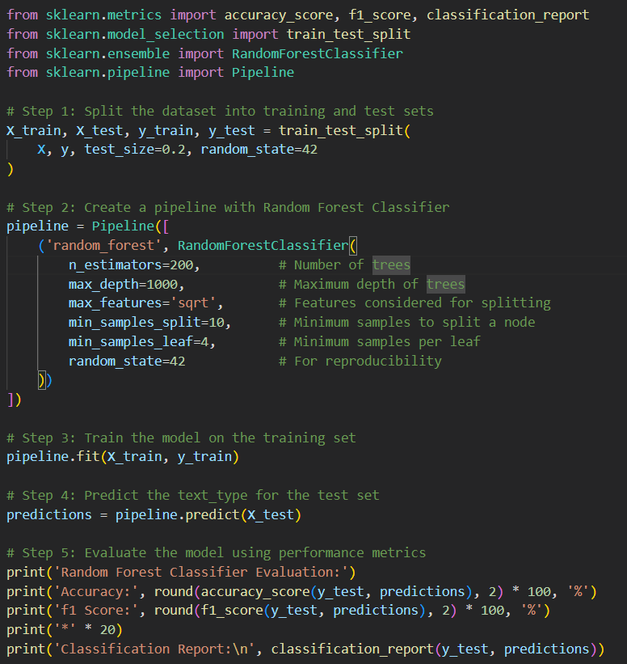

Figure : Base Random Forest

The RandomForestClassifier is configured within a pipeline to streamline model training. The model uses **200 trees** with a **maximum depth of 1000** to ensure detailed splits. Features are split based on the **square root of the total features**. To reduce overfitting, **a minimum of 10 samples** with **4 samples per leaf node is applied.** Next, the model trained on the training set and evaluated using **accuracy**, **precision**, **recall**, and **F1-score** of its performance.

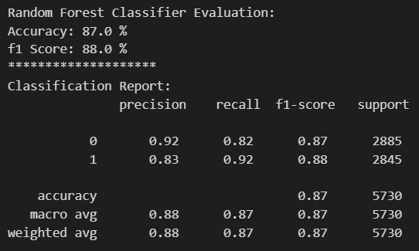

Figure : Base Random Forest Result

The base model achieved an accuracy of **87.0%**, a precision score of **88.0%**, a recall score of **87.0%**, and an F1 score of **88.0%**. The classification report shows that the model performs well in both classes, with Class 0(ham) having slightly higher precision and Class 1(spam) having higher recall. Further performance improvements may be achieved through hyperparameter tuning.

### 2.4 Gradient Boosting Machine

Gradient Boosting Machines (GBM) are a prominent machine learning technique for classification and regression in supervised learning. Utilizing boosting to convert "weak learners" (models marginally correlated with the target variable) into a "strong learner" (a model with robust predictive capability), GBM excels in modelling tabular data, particularly in decision tree ensembles (Guillen et al., 2023; Shwartz-Ziv & Armon, 2022). Its effectiveness has made it popular in data science competitions. GBM is applied across various fields, including predicting cardiovascular diseases, stock prices, and shoppers' purchase intentions, showcasing its versatility and robust predictive capabilities (Suhendra et al., 2023; Nakagawa & Yoshida, 2022; Abdullah-All-Tanvir et al., 2023)

GBMs are leading algorithms for tabular data due to their ability to capture complex, nonlinear relationships and their versatility in regression, classification, and ranking tasks, making them suitable for the task of spam message identification (Adler & Painsky, 2022; Dube & Verster, 2023). They can also address class imbalance effectively by focusing on difficult-to-classify spam cases, reducing misclassification errors and providing feature importance scores to identify key factors in spam detection (Low et al., 2021; Upadhyay et al., 2021).

**Base Gradient Boosting Model**

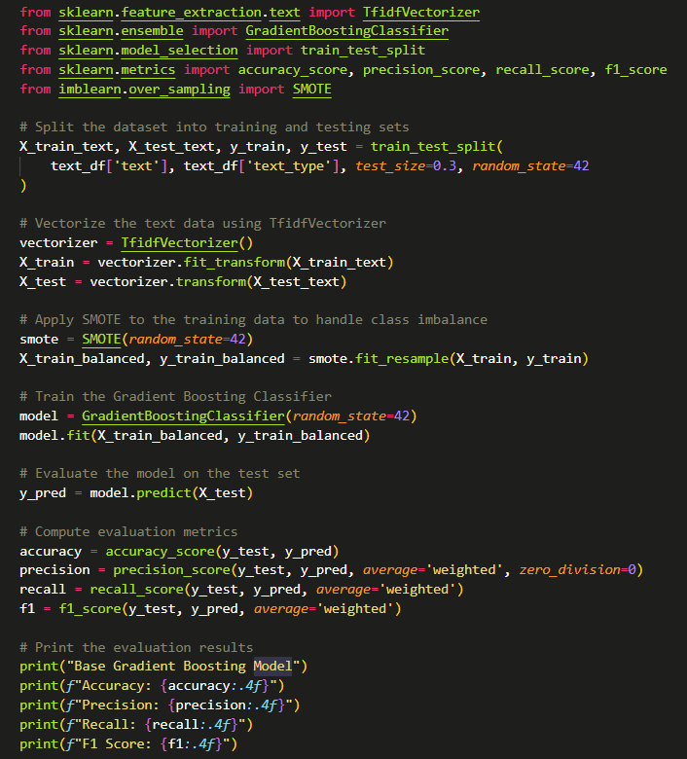

Figure : Base GBM.

The text is first converted into numerical with TfidfVectorizer to analyse word frequency. To tackle class imbalance, the SMOTE technique is applied to the training data by generating a balanced dataset through synthetic samples gathered from the minority class. The GBM is then trained using the balanced dataset and evaluated on accuracy, precision, recall, and F1 scores.

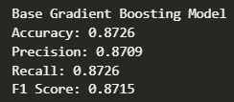

Figure : Base GBM results.

The model achieved an accuracy of 0.8726, precision score of 0.8709, recall score of 0.8726 and F1 score of 0.8715. These results are considered good, but we can further improve them with hyperparameter tuning.

## Q3 – Hyperparameter Selection

### 3.1 Hyperparameter Explanation

**Naïve Bayes Classifier**



Figure : Parameter of Multinomial Naïve Bayes Model

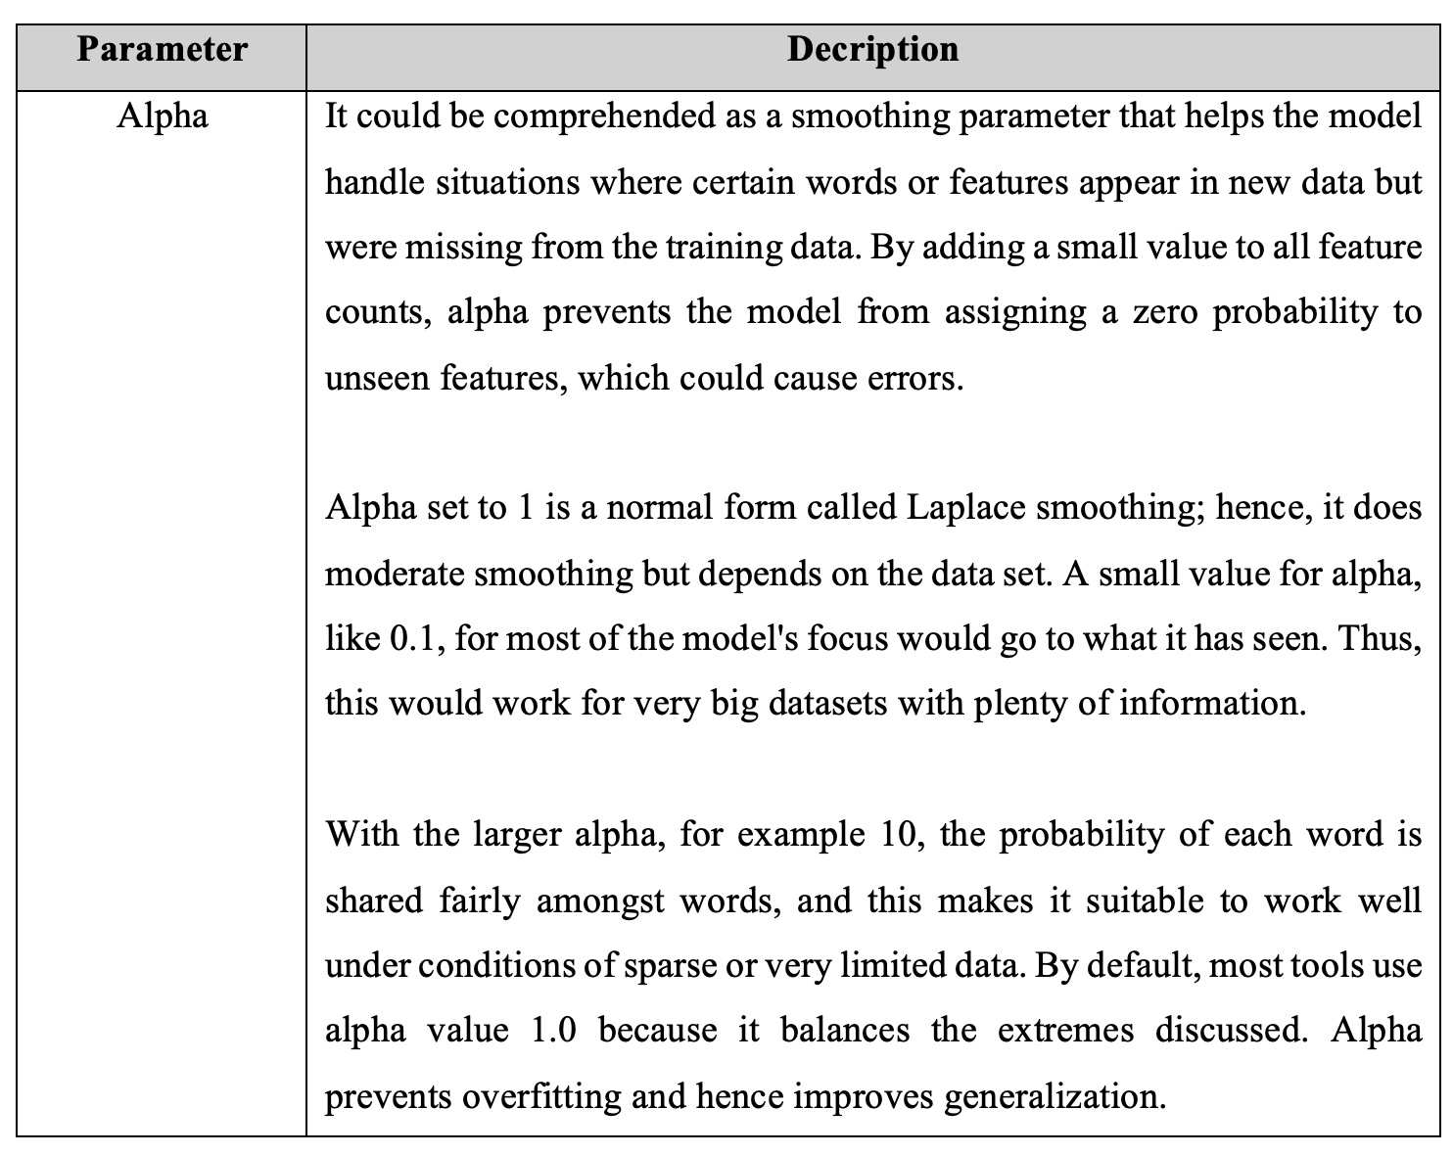

**Support Vector Machine (SVM)**

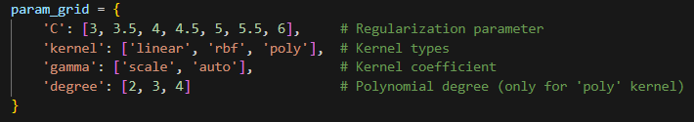

Figure : Parameter grid for SVM hyperparameter tuning

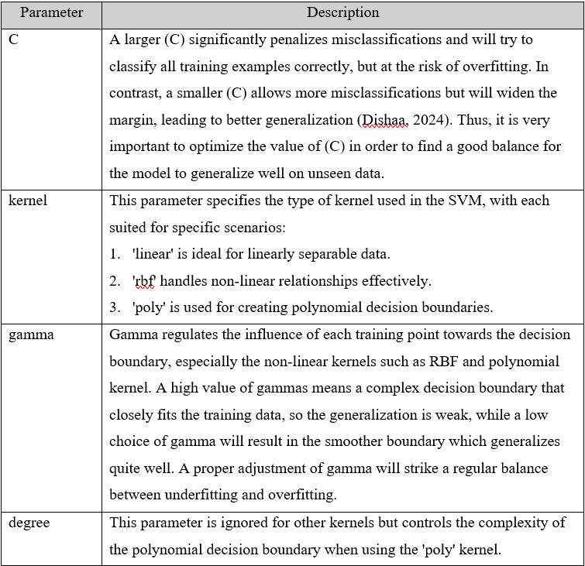

Figure : Explanation of SVM parameters.

**Random Forest**

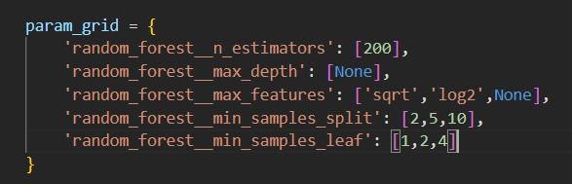

Figure : Parameter grid for RF hyperparameter tuning

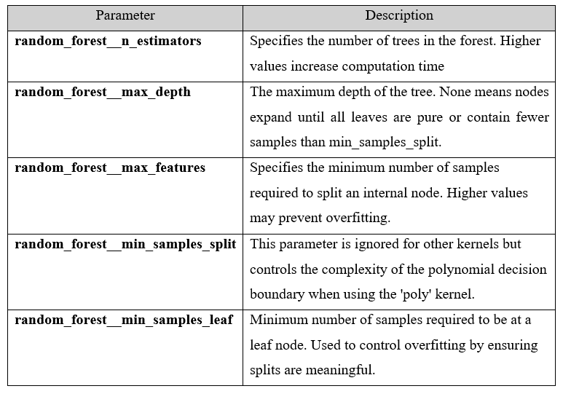

Figure ：RF tuning hyperparameters.

**Gradient Boosting Machine (GBM)**

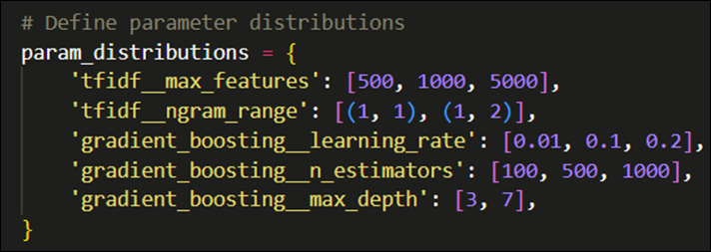

Figure : Parameter grid for GBM hyperparameter tuning.



Figure : GBM tuning hyperparameters.

### 3.2 Hyperparameter Tuning

**Multinomial Naïve Bayes Classifier**

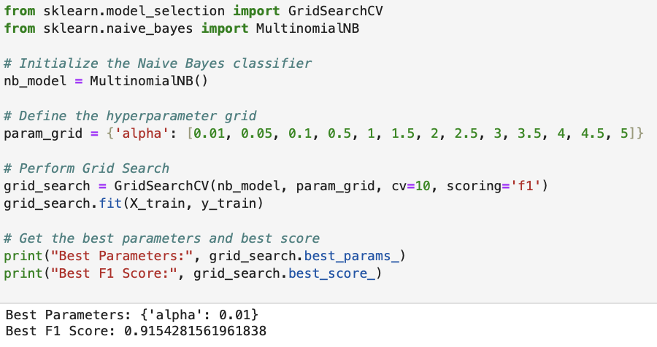

Figure : Code and Result of Hyperparameter Tuning of Naïve Bayes Model

The code above is demonstrating the way of using grid search to find out the best value for the alpha parameter for MNB model which has shown to be 0.01 with the F1 score of approximately 0.9154 by using 10-fold cross validation with figures ranging from 0.01 to 5 for alpha value.

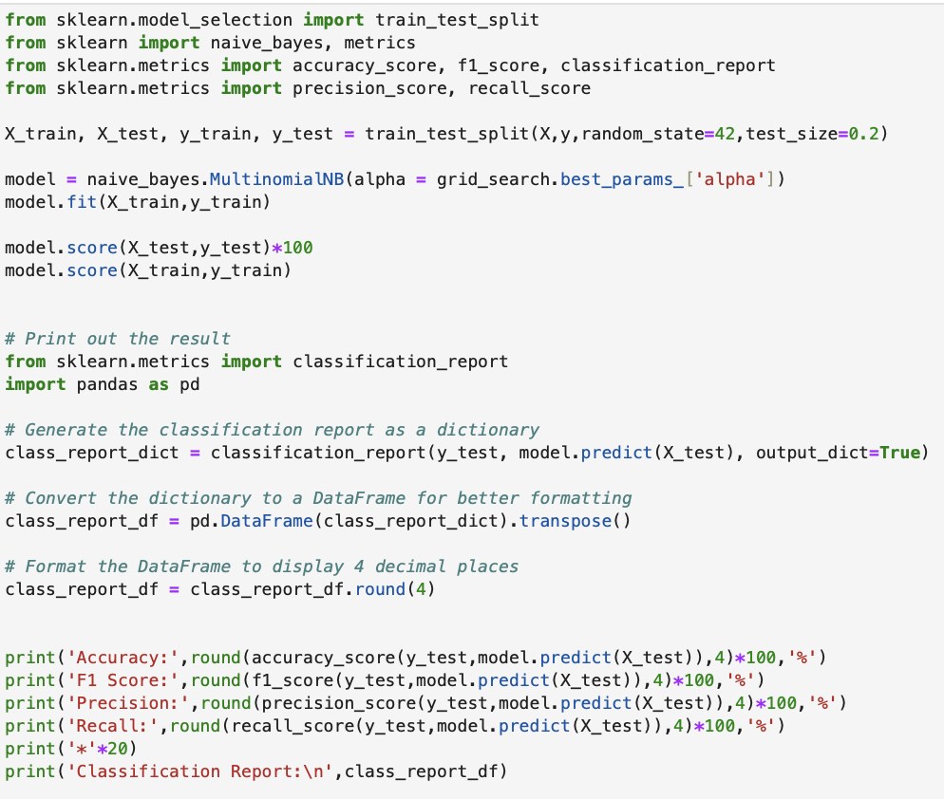

Figure : Adjusted Code of Multinomial NB Model with Hyperparameter

The code above shows the process of training the new MNB model by specifying the best alpha values obtained from the grid search.

**Support Vector Machine (SVM)**

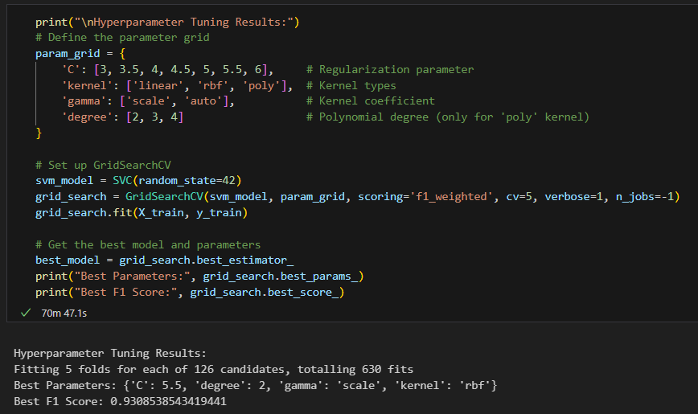

Figure : Hyperparameter tuning of the SVM model

The above code performs hyperparameter tuning for the SVM model using grid search on the defined parameter grid: C, kernel, gamma, and degree, while evaluating the best configuration in terms of weighted F1-score on 5-fold cross-validation.

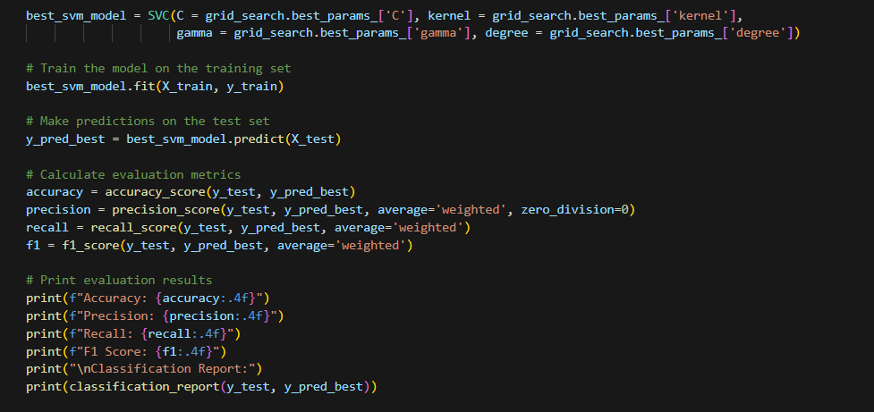

Figure : Configuration of optimal SVM parameter

Finally, the SVM model is configured with the parameters that achieve the best performance.

**Random Forest**

After experiment with different hyperparameter tuning methods, the best results were achieved using **GridSearchCV** with 5-fold cross-validation over 27 parameter combinations.

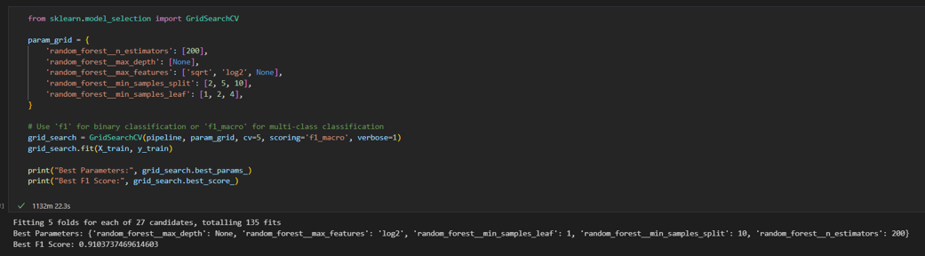

Figure : RF hyperparameter tuning with GridSearchCV with 5-fold cross validation.

The model was tuned using the F1-scoring method to achieve the best balance of performance across metrics.

|  |
| --- |
|  |

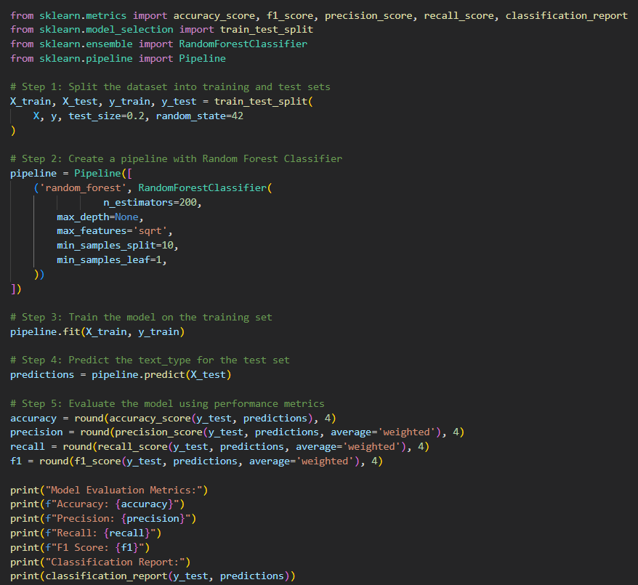

Figure : Building the RF with the best parameters.

The model is trained with the best hyperparameters and evaluated using key performance metrics.

**Gradient Boosting Machine (GBM)**

After vigorous experimentation with different hyperparameter tuning methods, the best results were found with 20 iterations of random search and 5-fold cross validation.

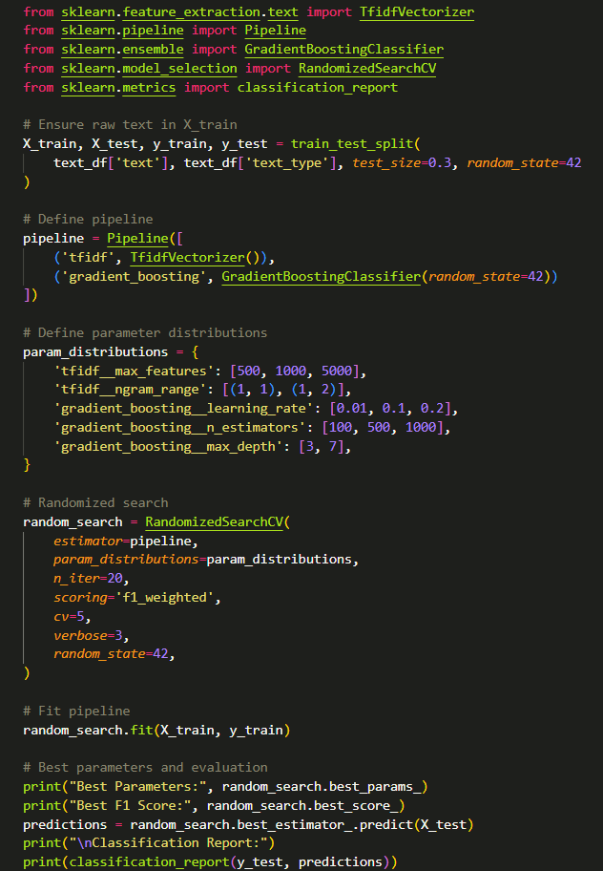

Figure : GBM hyperparameter tuning with Random Search and 5-fold cross validation.

The model was tuned on the F1-scoring method for the best balance of metric results.

|  |
| --- |
|  |

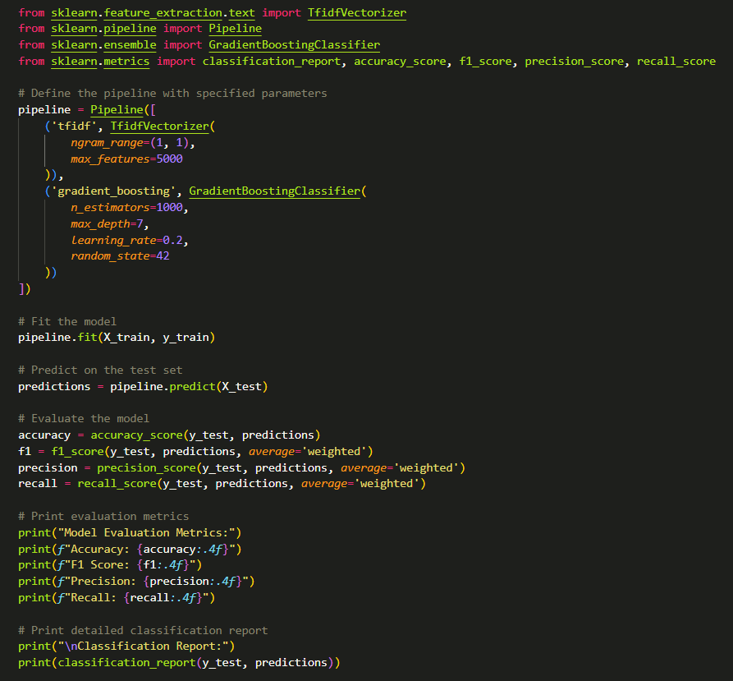

Figure : Building the GBM with the best parameters.

The GBM is finally fitted with the best parameters and evaluated with metrics.

## Q4. Evaluation and Discussion of Predictive Model’s Results

### 4.1 Evaluation Metrics

The selected evaluation metrics for the models were accuracy, precision, recall and F1-scores. For all metrics, it ranges from 0.0 to 1.0, where the worst and the best scores are defined as the former and latter score respectively.

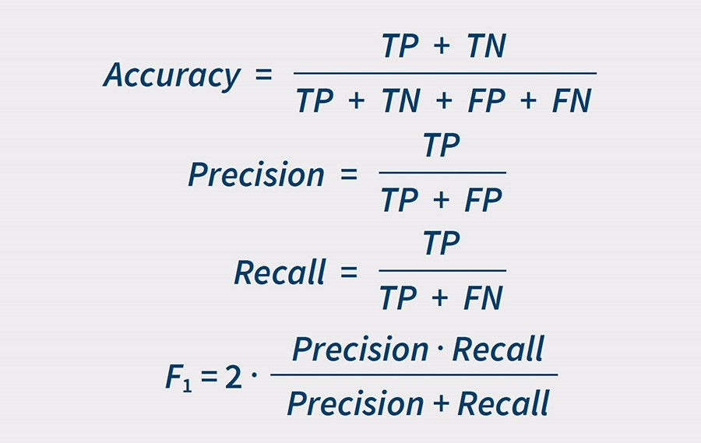

Figure : Evaluation metrics formulas.

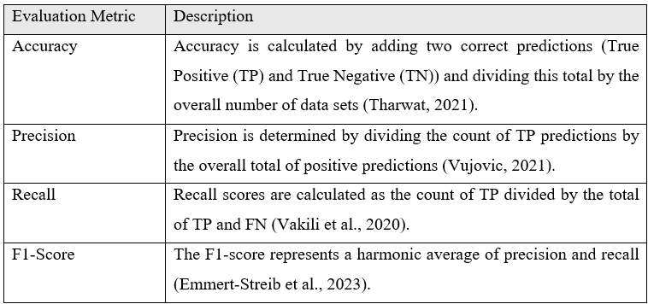

Figure : Evaluation metrics explanation.

### 4.2 Result Evaluation

**Multinomial Naïve Bayes**

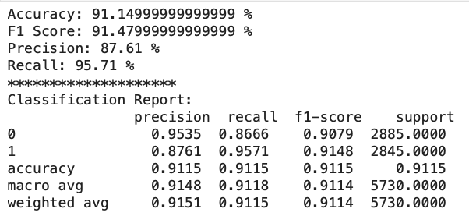

Figure : Result of Tuned Multinomial Naïve Bayes

After specifying the alpha value obtained from the grid search, the model’s accuracy and F1 score has been increase by around 1%. With both matrices, it is indicating the correctness and consistency model’s prediction has been increased by 1%. On the other hand, the precision and recall value for labelling the case as spam case are 87.61% and 95.71% meaning the model is good at identifying the ‘spam’ case and might have high chance to misclassify the ‘non-spam’ case as spam which is still considered tolerable since the main goal is to identify the spam message.

**Support Vector Machines (SVM)**

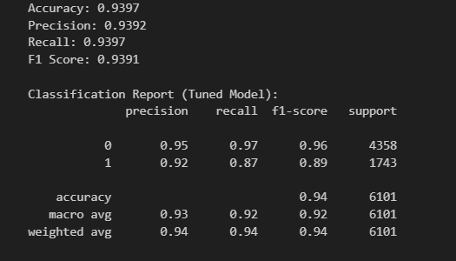

Figure : Result of Tuned SVM Model

After hyperparameter tuning, the performance of the SVM model improved on all metrics compared to the base model. The accuracy increased from **93.46%** to **93.97%**, while precision, recall, and F1-score also slightly increased, the latter rising from **0.9339** to **0.9391**. Particularly, the tuned model increased recall for class 1 (spam message), the target class, by improving it from **0.85** to **0.87**, thus addressing the misclassification in the minority class. In general, tuning made the model well-balanced and effective.

**Random Forest**

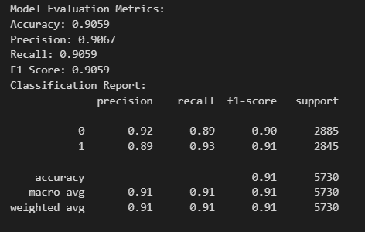

Figure : Result of tuned Random Forest.

After applying the tuned hyperparameters, the Random Forest model has demonstrated significant improvement in its evaluation metrics. The accuracy increased from **87.0%** to **90.59%**, and the F1-score rose from **88.0%** to **90.59%** too, indicating an approximate 2% improvement in both metrics. While this increase might appear modest, it reflects a meaningful enhancement in the model’s ability to make consistent and accurate predictions. Furthermore, the precision and recall values improved to **90.67%** and **90.59%**, respectively, highlighting the model's strong ability to correctly identify cases while maintaining a balanced performance across classes.

**Gradient Boosting Machine (GBM)**

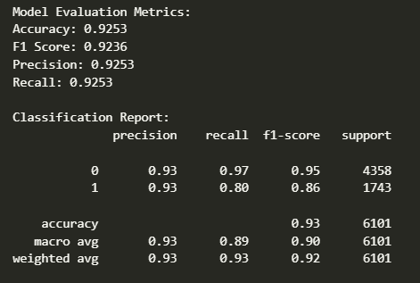

Figure : Result of the tuned GBM.

The tuned GBM has attained an impressive improvement in its metrics after tuning, raising its accuracy from **87.26%** to an average accuracy of **92.53%**, its precision score from **87.09%** to **92.36%**, the recall score from **87.25%** to **92.53%** and an F1-score from **87.15%** to **92.53%**. The model has higher precision on classifying spam messages; however, its recall and F1-scores are lower compared to the non-spam messages due to the class imbalance. Nevertheless, the model has achieved impressive metric scores and a substantial improvement after tuning its hyperparameters as its weighted averages prove that the model performs consistently across both classes.

### 4.3 Model Comparison

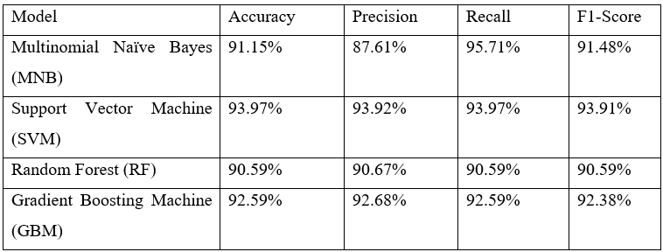

Figure : Results of tuned models.

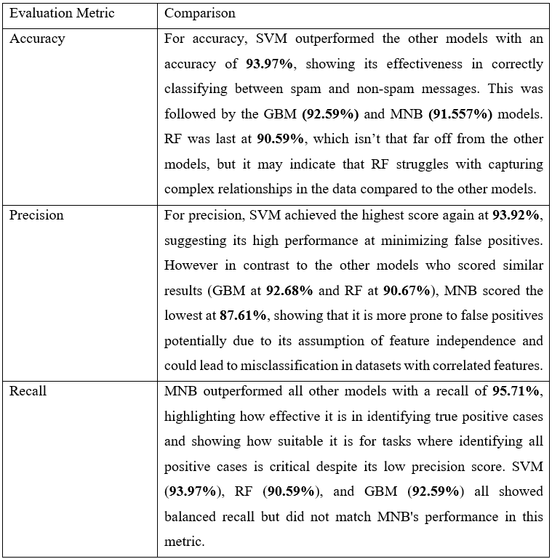

Figure : Comparison of evaluation metrics between models (1).

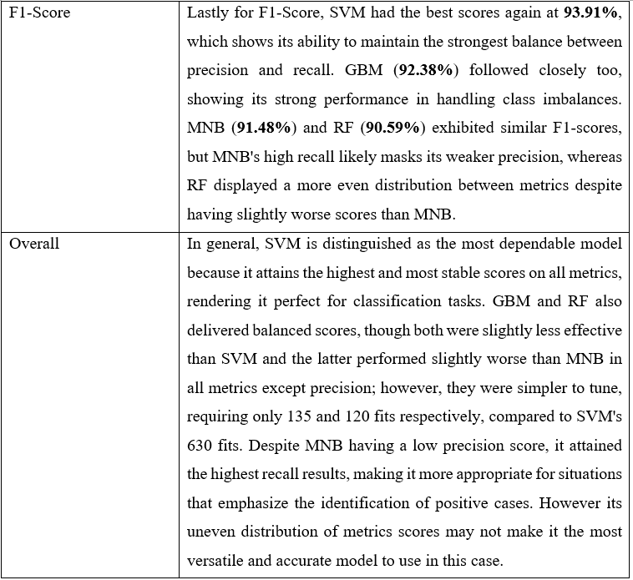

Figure : Comparison of evaluation metrics between models (2).

**TOTAL 3674 WORDS**

## References

* Top of Form
* Bottom of Form

Abdullah-All-Tanvir, Ali Khandokar, I., Muzahidul Islam, A. K. M., Islam, S., & Shatabda, S. (2023). A gradient boosting classifier for purchase intention prediction of online shoppers. Heliyon, 9(4), e15163. <https://doi.org/10.1016/j.heliyon.2023.e15163>

Abid, M. A., Ullah, S., Siddique, M. A., Mushtaq, M. F., Aljedaani, W., & Rustam, F. (2022). Spam SMS filtering based on text features and supervised machine learning techniques. *Multimedia Tools and Applications*, *81*(28), 39853–39871. <https://doi.org/10.1007/s11042-022-12991-0>

Adler, A. I., & Painsky, A. (2022). Feature Importance in Gradient Boosting Trees with Cross-Validation Feature Selection. Entropy, 24(5), Article 5. <https://doi.org/10.3390/e24050687>

Airlangga, G. (2024). Optimizing SMS spam detection using Machine Learning: A comparative analysis of ensemble and traditional classifiers. *Journal of Computer Networks Architecture and High Performance Computing*, *6*(4), 1942–1951. <https://doi.org/10.47709/cnahpc.v6i4.4822>

Amarappa, S., & Sathyanarayana, S. V. (2014). Data classification using Support vector Machine (SVM), a simplified approach. International Journal of Electronics and Computer Science Engineering, 3, 435-445.

Amayri, O., & Bouguila, N. (2010). A study of spam filtering using support vector machines. *Artificial Intelligence Review*, *34*(1), 73–108. <https://doi.org/10.1007/s10462-010-9166-x>

Bermejo, P., Gámez, J. A., & Puerta, J. M. (2010). Improving the performance of Naive Bayes multinomial in e-mail foldering by introducing distribution-based balance of datasets. Expert Systems With Applications, 38(3), 2072–2080. <https://doi.org/10.1016/j.eswa.2010.07.146>

Bo'riboyevna, A. G. Z., & Bo'riboyevna, A. D. (2023). Support vector machine algorithm. Central asian journal of mathematical theory and computer sciences, 4(5), 164-167.

BotPenguin. (2024, June 8). Stemming and Lemmatization: Benefits and How it Works. <https://botpenguin.com/glossary/stemming-and-lemmatization>

Bouke, M. A., Alramli, O. I., & Abdullah, A. (2024). XAIRF-WFP: a novel XAI-based random forest classifier for advanced email spam detection. *International Journal of Information Security*, *24*(1). <https://doi.org/10.1007/s10207-024-00920-1>

Dishaa. (2024, December 9). Introduction Support Vector Machines (SVM) with Python Implementation. Analytics Vidhya. <https://www.analyticsvidhya.com/blog/2021/04/insight-into-svm-support-vector-machine-along-with-code/>

Dube, L., & Verster, T. (2023). Enhancing classification performance in imbalanced datasets: A comparative analysis of machine learning models. Data Science in Finance and Economics, 3, 354–379. <https://doi.org/10.3934/DSFE.2023021>

Emmert-Streib, F., Moutari, S., & Dehmer, M. (2023). Elements of Data Science, Machine Learning, and Artificial Intelligence Using R. Springer International Publishing. <https://doi.org/10.1007/978-3-031-13339-8>

GeeksForGeeks. (2024, April 5). *Feature Importance with Random Forests*. GeeksforGeeks. <https://www.geeksforgeeks.org/feature-importance-with-random-forests/>

Guillen, M. D., Aparicio, J., & Esteve, M. (2023). Gradient tree boosting and the estimation of production frontiers. Expert Systems with Applications, 214, 119134. <https://doi.org/10.1016/j.eswa.2022.119134>

Gupta, S. S. (2022, December 12). Normalization of text in NLP - Scaler topics. Scaler Topics. <https://www.scaler.com/topics/nlp/what-is-text-normalization-in-nlp/>

Learn Statistics Easily. (2024, March 29). *Random Forest in Practice: An Essential Guide*. LEARN STATISTICS EASILY. <https://statisticseasily.com/random-forest/>

Low, R., Cheah, L., & You, L. (2021). Commercial Vehicle Activity Prediction With Imbalanced Class Distribution Using a Hybrid Sampling and Gradient Boosting Approach. IEEE Transactions on Intelligent Transportation Systems, 22(3), 1401–1410. IEEE Transactions on Intelligent Transportation Systems. <https://doi.org/10.1109/TITS.2020.2970229>

Mammone, A., Turchi, M., & Cristianini, N. (2009). Support vector machines. Wiley Interdisciplinary Reviews Computational Statistics, 1(3), 283–289. <https://doi.org/10.1002/wics.49>

Meena, M. (2020, December 8). *Applications of Random Forest*. OpenGenus IQ: Learn Computer Science. <https://iq.opengenus.org/applications-of-random-forest/>

Metsis, V., Androutsopoulos, I., & Paliouras, G. (2006). Spam Filtering with Naive Bayes - Which Naive Bayes? Conference on Email and Anti-Spam. <http://cs.txstate.edu/~v_m137/docs/papers/ceas2006_paper_corrected.pdf>

Moral, C., de Antonio, A., Imbert, R., & Ramírez, J. (2014). A survey of stemming algorithms in information retrieval. *Information Research, 19*(1), paper 605. <http://InformationR.net/ir/19-1/paper605.html>

Muneeb, A. (2024, September 9). *Understanding Random Forest Algorithm: A Comprehensive Guide*. Data Science Dojo. <https://datasciencedojo.com/blog/random-forest-algorithm>

Naeem, M. Z., Rustam, F., Mehmood, A., Mui-Zzud-Din, N., Ashraf, I., & Choi, G. S. (2022). Classification of movie reviews using term frequency-inverse document frequency and optimized machine learning algorithms. PeerJ Computer Science, 8, e914. <https://doi.org/10.7717/peerj-cs.914>

Nakagawa, K., & Yoshida, K. (2022). Time-series gradient boosting tree for stock price prediction. International Journal of Data Mining, Modelling and Management, 14, 110. <https://doi.org/10.1504/IJDMMM.2022.123357>

NLTK. (n.d.). NLTK :: Sample usage for gensim. NLTK. Retrieved October 23, 2024, from <https://www.nltk.org/howto/gensim.html>

*Random Forest Algorithm Use Cases | Restackio*. (2024). Restack.io. <https://www.restack.io/p/machine-learning-answer-random-forest-use-cases-cat-ai?=>

Reddy, K. S., & Gayathri, A. (2023). Classification of spam detection using random forest algorithm over naive bayes algorithm based on accuracy. *AIP Conference Proceedings*, *2821*, 020034. <https://doi.org/10.1063/5.0166577>

Rianto, N., Mutiara, A. B., Wibowo, E. P., & Santosa, P. I. (2021). Improving the accuracy of text classification using stemming method, a case of non-formal Indonesian conversation. Journal of Big Data, 8(1). <https://doi.org/10.1186/s40537-021-00413-1>

Saumyab. (2024, October 21). Stemming vs Lemmatization in NLP: Must-Know Differences. Analytics Vidhya. <https://www.analyticsvidhya.com/blog/2022/06/stemming-vs-lemmatization-in-nlp-must-know-differences/>

scikit-learn. (n.d.A). *TFIDFVectorizer*. Scikit-learn. <https://scikit-learn.org/1.5/modules/generated/sklearn.feature_extraction.text.TfidfVectorizer.html>

scikit-learn. (n.d.B). GradientBoostingClassifier. Scikit-Learn. Retrieved December 8, 2024, from <https://scikit-learn/stable/modules/generated/sklearn.ensemble.GradientBoostingClassifier.html>

Sharma, N., & Singh, M. (2016, December 1). Modifying Naive Bayes classifier for multinomial text classification. <https://doi.org/10.1109/icraie.2016.7939519>

Shwartz-Ziv, R., & Armon, A. (2022). Tabular data: Deep learning is not all you need. Information Fusion, 81, 84–90. <https://doi.org/10.1016/j.inffus.2021.11.011>

Singh, G., Kumar, B., Gaur, L., & Tyagi, A. (2019). Comparison between Multinomial and Bernoulli Naïve Bayes for Text Classification. 2019 International Conference on Automation, Computational and Technology Management (ICACTM). <https://doi.org/10.1109/icactm.2019.8776800>

Stemming. (n.d.). Fiveable. <https://library.fiveable.me/key-terms/cognitive-computing-in-business/stemming>?

Suhendra, R., Husdayanti, N., Suryadi, A., Juliwardi, I., Sanusi, S., Ridho, A., Ardiansyah, M., Murhaban, M., & Ikhsan, I. (2023). Cardiovascular Disease Prediction Using Gradient Boosting Classifier. Infolitika Journal of Data Science, 1, 56–62. <https://doi.org/10.60084/ijds.v1i2.131>

Tekerek, A. (2018). Destek vektör makineleri kullanılarak spam SMS tespiti. *Journal of Polytechnic*, *22*(3), 779–784. https://doi.org/10.2339/politeknik.429707

TextBlob Reviews, Pricing and Features—2024. (n.d.). Retrieved October 23, 2024, from <https://www3.technologyevaluation.com/solutions/53875/textblob>

Tharwat, A. (2021). Classification assessment methods. Applied Computing and Informatics, 17(1), 168–192. <https://doi.org/10.1016/j.aci.2018.08.003>

Thing Thing, G., Akmal, N., Mohamed, H., Ismail, M., & Chua Mason, H. S. (2022). A Comparative Study on Part-of-Speech Taggers’ Performance on Examination Questions Classification According to Bloom’s Taxonomy. Journal of Physics: Conference Series, 2224, 012001. <https://doi.org/10.1088/1742-6596/2224/1/012001>

Top text analytics Companies. (n.d.). <https://www.greenbook.org/market-research-firms/text-analytics>

Upadhyay, D., Manero, J., Zaman, M., & Sampalli, S. (2021). Gradient Boosting Feature Selection With Machine Learning Classifiers for Intrusion Detection on Power Grids. IEEE Trans. on Netw. and Serv. Manag., 18(1), 1104–1116. <https://doi.org/10.1109/TNSM.2020.3032618>

Vakili, M., Ghamsari, M., & Rezaei, M. (2020, January 27). Performance analysis and comparison of machine and deep learning algorithms for IoT data classification. arXiv.org. <https://arxiv.org/abs/2001.09636>

Vijayasekaran, G., & Rosi, S. (2018). Spam and email detection in big data platform using naives bayesian classifier. *International Journal of Computer Science and Mobile Computing*, *7*(4), 53-58.

Vujovic, Z. (2021). Classification Model Evaluation Metrics. International Journal of Advanced Computer Science and Applications, Volume 12, 599–606. <https://doi.org/10.14569/IJACSA.2021.0120670>